**Citation:**

Brady, W.J., Gantman, A.P. & Van Bavel, J.J. (in press). *Journal of Experimental Psychology: General*.

**Attentional capture helps explain why moral and emotional content go viral**

William J. Brady1, Ana P. Gantman2 & Jay J. Van Bavel3,4

1Yale University, Department of Psychology

2Brooklyn College, Department of Psychology

3New York University, Department of Psychology

4New York University, Center for Neural Science

Word Count: 6,933

Author Note

Correspondence concerning this article should be addressed to Jay Van Bavel, Department of Psychology, New York University. Contact: jay.vanbavel@nyu.edu.

Author Contributions: W.J.B., A.P.G. and J.J.V.B. designed research; W.J.B. performed research; W.J.B. and J.J.V.B. planned analyses; W.J.B. analyzed data; W.J.B. wrote the paper and all authors contributed to revisions.

Acknowledgments: We thank Miaohan Wang for assistance with data collection. We are also grateful to members of the NYU Social Perception and Evaluation Lab (@vanbavellab) for their comments and suggestions.

Grants: This research was supported by the Foundation for Personality and Social Psychology Heritage Dissertation Award as well as a National Science Foundation grant (#1349089) to JJVB and NYU Challenge Grants to WJB, APG, and JVB.

**Abstract**

Our social media newsfeeds are filled with a variety of content all battling for our limited attention. Across three studies, we investigated whether moral and emotional content captures our attention more than other content and if this may help explain why this content is more likely to go viral online. Using a combination of controlled lab experiments and nearly 50,000 political tweets, we found that moral and emotional content are prioritized in early visual attention more than neutral content, and that such attentional capture is associated with increased retweets during political conversations online. Furthermore, we found that the differences in attentional capture among moral and emotional stimuli could not be fully explained by differences in arousal. These studies suggest that attentional capture is one basic psychological process that helps explain the increased diffusion of moral and emotional content during political discourse on social media, and shed light on ways in which political leaders, disinformation profiteers, marketers, and activist organizations can spread moralized content by capitalizing on natural tendencies of our perceptual systems.

*Keywords:* morality, emotion, attention, social networks, social media

**Attentional capture helps explain why moral and emotional content go viral**

There are now over 3 billion social media users around the globe (Williams, 2017). These online social media environments are often described as an, “attention economy” (Williams, 2018), as content must break through an immense stream of noise in order to be noticed. Our social media newsfeeds are filled with $15 billion worth of advertisements bought annually by U.S. companies (Statistica, 2015), news and disinformation, passionate political debates, viral memes, and personal updates from our social network—all battling for our limited attention. Because noticing content is a necessary precursor to engagement (e.g., sharing, commenting, liking), attention serves as a bottleneck partially determining which content draws user engagement online. In short, the ability for content to capture attention may be a necessary prerequisite to reach a large audience (i.e., go viral) and exert social influence in domains such as morality and politics (Jost et al., 2018).

Several recent studies have found that social media communications containing expressions of morality and emotion are consistently associated with increased virality in the context of moral and political discourse (Brady, Wills, Jost, Tucker, & Van Bavel, 2017; Stieglitz & Dang-Xuan, 2013; Valenzuela, Piña, & Ramírez, 2017) and campaigns for social change (Van Der Linden, 2017). However, the psychological processes that explain *why* moral and emotional content tend to go viral currently remains untested. If attention is a bottleneck for user engagement on social media, then the ability for moral and emotional content to break through and capture our attention may play an important role in their subsequent diffusion. By ‘attentional capture’ we mean prioritized selective processing where ‘prioritized’ means shifting of cognitive resources to the attended stimuli over others (e.g., Öhman & Mineka, 2001). This paper examines the extent to which moral and emotional content—associated with greater diffusion on social media—captures more attention than neutral content, and link experimental data from laboratory measures of attention to real-world social media sharing behavior.

Moral and emotional content have a high potential to capture attention because both emotional and moral stimuli are motivationally relevant (Brosch & Van Bavel, 2012; Gantman & Van Bavel, 2015). A stimulus is motivationally relevant if it can affect attainment of a goal. Stimuli that affect goal attainment tend to be prioritized in visual attention (Dijksterhuis & Aarts, 2010). Moral stimuli are motivationally relevant because morality fulfils numerous goals, including the need to belong in social groups (Haidt, 2012) and the need to believe in a ‘just’ world (Lerner & Miller, 1978), and there is evidence that moral stimuli capture attention more than non-moral stimuli (Gantman & Van Bavel, 2015). For example, people are more likely to identity a moral word than a matched non-moral word when both were flashed briefly on screen near the threshold of conscious perception. Further, when people had their need for justice activated, justice-related words captured attention more than non-justice related words (Baumert, Gollwitzer, Staubach, & Schmitt, 2011), and moral words (e.g. ‘obey’, ‘duty’, ‘law’) were more likely to ‘pop out’ in conscious perception than neutral words (Gantman & Van Bavel, 2016). More broadly, when forming impressions about people and groups, moral character is one of the primary dimensions to which people attend (Brambilla & Leach, 2014; Goodwin, 2015). For example, studies that experimentally manipulate the moral goodness of a target have found that participants form more positive impressions of the person when they learn the person is morally good, even if other dimensions (e.g. warmth) are also manipulated (Goodwin, Piazza, & Rozin, 2014). Thus, moral content captures our attention because it fulfills our goals and help us learn about our social world (Gantman & Van Bavel, 2016).

Emotional stimuli tend to be highly motivationally relevant because they are associated with various goals (Todd, Cunningham, Anderson, & Thompson, 2012), including survival goals (e.g., detecting a snake; Ohman, Flykt, & Esteves, 2001) and social goals (e.g., understanding social behavior; Campos et al., 1994). Indeed, there is a large body of evidence suggesting that emotional stimuli are also prioritized in visual attention. For instance, emotional words are more easily identified compared to neutral words—especially under conditions of limited attentional resources (Anderson & Phelps, 2001; Anderson, 2005; Keil & Ihssen, 2004; Milders, Sahraie, Logan, & Donnellon, 2006). Furthermore, emotional stimuli can drive attentional capture in an automatic, stimulus-driven fashion (Arnell, Killman, & Fijavz, 2007; Ciesielski, Armstrong, Zald, & Olatunji, 2010; Most, Smith, Cooter, Levy, & Zald, 2007; Most & Wang, 2011). Thus, emotional stimuli can shape perceptual experience through decreased thresholds for attentional capture (see Phelps, Ling, & Carrasco, 2006), leading people to notice emotional content.

Current Research

The aim of the current research was to test whether attentional capture can help explain the advantage that moral and emotional content has over other content in spreading on social media. We further explored whether basic psychological characteristics such as arousal underlie attentional capture of moral and emotional stimuli. This research is also one of the first attempts to tie basic cognitive psychology methods to real social media behavior. The following studies use the classic ‘Attentional Blink’ (AB) paradigm (Raymond, Shapiro, & Arnell, 1992) to assess the difference in attentional capture between moral and non-moral emotion content compared to neutral content (Studies 1 and 2). To simulate the ecology of real social media use, we also created a modified version of the AB paradigm that uses complete Twitter messages as stimuli similar to the way people scroll through their social media feeds (Study 2). Finally, we measured the extent to which individual words capture attention in the lab is associated with sharing behavior (i.e., retweeting) in a large data set of 50,000 political messages on Twitter (Study 3). These studies provide a key test of the cognitive factors that underlie sharing of moralized content on social media.

Study 1: How moral and emotional content captures attention

Study 1 examined whether moral and emotional content captures more attention than neutral content by testing specific words associated with morality and emotion in the attentional blink paradigm (Raymond et al., 1992). The attentional blink task simulates the experience of many users on social media as they rapidly scroll through posts and messages in their news feed. This task allowed us to conduct a precise experimental test of the capacity for different types of language to capture attention.

## **Method**

In the attentional blink paradigm, identification of a first target (T1) during rapid serial presentation of stimuli impairs the ability for identification of a second target (T2). The period when people are typically unable to identify T2 is known as the ‘attentional blink’ (AB), and lasts between 200-500ms (Raymond et al., 1992). We adapted a modified version of the AB paradigm in which we manipulated the moral and emotional content of words that appeared as T2 (e.g., Anderson & Phelps, 2001; see Fig. 1). This allowed us to replicate prior work on emotional attention, while extending these processes to morality (and providing a database of attentional capture we could link to real behavior on Twitter). To the extent that moral or emotional words a reduce the AB effect (as assessed by T2 accuracy) it can be inferred that those words capture greater attention than words that show less of a reduction. In other words, we examined whether moral and emotional words were less likely to elicit an attention blink.

*Participants.* Fifty-one undergraduate students at New York University (46 females; *M*age = 19.66, *SDage* = 1.37) participated for partial course credit. We intended to collect 50 participants based on an *a priori* power analysis using *G*Power 3.1.9.2* to determine the sample size required to detect a small-to-medium (*f* = .15)main effect of word type with 80% power based on the following assumptions: (1) a within-subjects design with 6 repeated measures (see below) and (2) a correlation among repeated measures of at least .5. This power analysis was conservative because it assumed we averaged across trials and performed a repeated-measures ANOVA, but in actuality we utilized a larger amount of data by analyzing data at the trial and stimulus level using a mixed model (see “Results”). Seven participants were removed from the data set due to mean accuracy in early phase trials (see below) under 25%, leaving a final sample size of 44. However, the reported results are consistent when these participants remain in the data set (see SI Appendix, Section 1).

*Procedure.* Participants were told that the experiment was about word recognition and vision. The concepts of morality and emotion were not mentioned in the instructions. The task was performed in DirectRT software on a Dell Optiplex 760 with a 60hz refresh rate. Participants completed the study in a dimly lit room and sat approximately 20 inches from the screen. All stimuli were presented in 24 pt, Times New Roman font at the center of the screen. The background was white, and all non-target words were black. Participants were instructed to identify two target words that would appear in green, and at the end of each trial they were prompted to type the two green words they saw, in any order.

Each trial consisted of 15 words (13 distractors and 2 targets) displayed for 100 ms at a time. Distractors were neutral words of longer length than the target words to serve as a visual mask for following stimuli (Anderson & Phelps, 2001). T1 appeared after fixation at a jittered position after 1-4 distractor words to avoid anticipation. T2 appeared between 1 to 7 positions, or “lags” after T1 (Raymond et al., 1992; see Fig. 1). Participants completed 224 total trials consisting of 56 trials for each of four possible T2 word types: distinctly moral, distinctly emotional, moral-emotional, and neutral words. Within the 56 trials of each word type, there were 2 trials per lag phase (1-7), such that each word type was presented an equal number of times in each lag phase. Within each type, words were assigned to each lag phase randomly, and trials were presented in randomized order. Participants were offered an optional 1-minute break halfway through the experiment. All together, the experiment is a 4 (word type: moral, emotional, moral-emotional, and neutral x 2 (early vs. late lag) within subjects design.

*Stimuli*

28 words per category were determined based on an random selection of words from previously-validated lexicon-based measures of morality and emotion in language (Brady et al., 2017). This approach distinguishes between distinctly moral words (‘church’, ‘holy’, ‘pure’), distinctly emotional words (‘weep’, ‘sad’, ‘afraid’), and moral-emotional words (e.g., ‘hate’, ‘shame’, ‘ruin’). Neutral words were chosen that were not classified as any of the other word types and to avoid confounds that could be related to attention, all word categories were matched for (1) length, (2) frequency in the English language, (3) number of orthographic neighbors, and (4) number of phonological neighbors (see SI Appendix, Section 1). All words, organized by category, are presented in SI Appendix, Table S1 and materials freely available to researchers at <https://osf.io/z6evq/>.

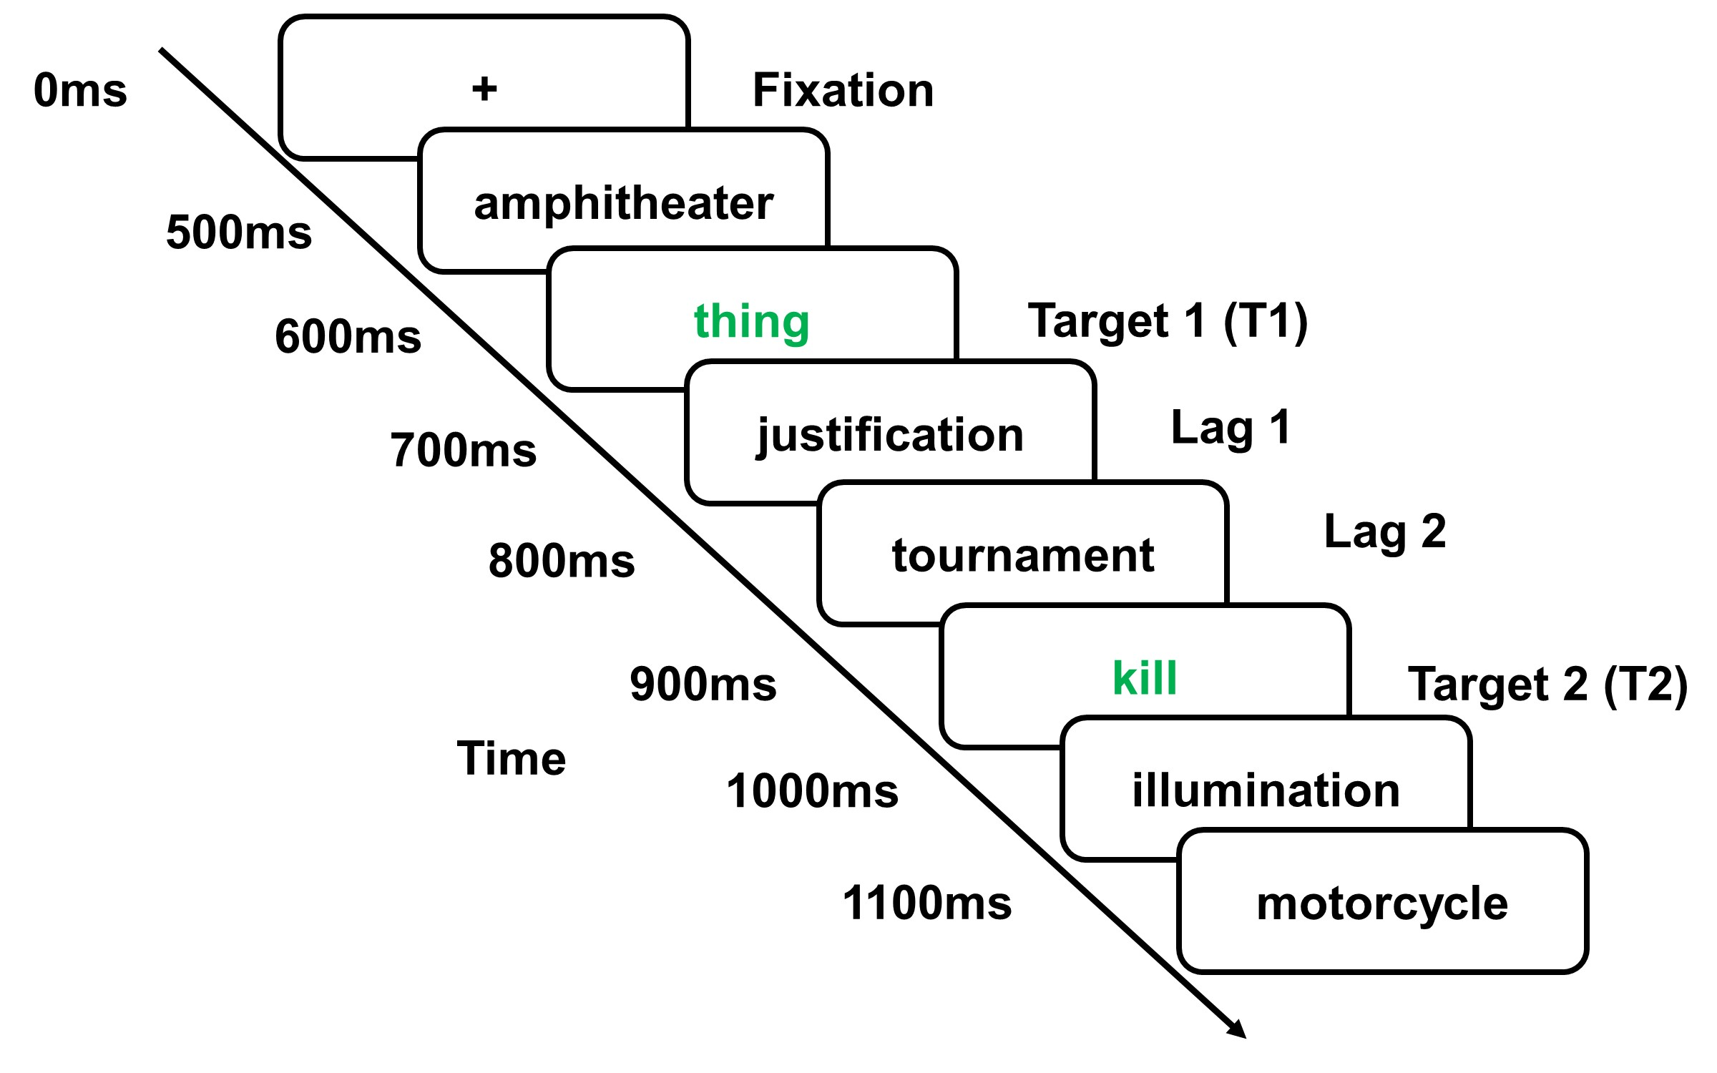

**Fig. 1. Modified attentional blink paradigm.** Participants viewed rapidly presented words in 100ms intervals. Their task was to identify two target words that appeared in green. The first target (T1) appeared after fixation at a jittered position after 1-4 distractor words. The second target (T2) appeared 1-7 words after T1, represented as the “lag” position (e.g. Lag 1). This figure depicts a trial where T2 appears at Lag 3. For each trial, T2 was a word from one of four categories: distinctly moral, distinctly emotional, moral-emotional and neutral. Images are not shown to scale.

## **Results**

*Data preprocessing.* All trials for which participants did not correctly identify T1 were dropped, as these trials represent those where an attentional blink effect cannot be assessed (Anderson & Phelps, 2001; Keil & Ihssen, 2004). Lag phase was collapsed to a binary variable where lags 1-3 were coded as “early lag” and lags 4-7 were coded as “late lag” ( Anderson & Phelps, 2001), but results did not change when modeling lag continuously (see SI Appendix, Section 1). Word type was treated as a categorical variable with 4 levels (distinctly moral, distinctly emotional, moral-emotional, neutral) and therefore was entered into the regression model as 3 dummy-coded variables where the reference level was not entered. T2 accuracy was treated as a binary variable where 1 = correct word identification and 0 = incorrect word identification.

*Main analyses.* In order to test whether the attentional blink was reduced as a function of the T2 word type, we regressed T2 accuracy on word category, lag phase, and their interaction using each trial as an observation. To account for correlation in variance among stimuli and participants, we formed a multi-level model with trials nested within stimuli, and stimuli nested within participants using generalized estimating equations (GEE; Hardin, 2005) with robust standard error estimation and an exchangeable correlation structure (all analysis scripts are available at <https://osf.io/z6evq/>).

As expected, there was a significant main effect of lag, odds-ratio (OR) = 2.90, *p* < .001, 95% CI = [2.42, 3.46], such that participants were 2.9x more accurate in late lags compared to early lags. We then examined whether moral and emotional words reduced the attentional blink relative to neutral control words. Critically, there were significant effects of all T2 word types compared to neutral words. Participants were 1.43x more likely to correctly identify a distinctly *moral* T2 word compared to a neutral T2 word, OR = 1.43, *p* <.001, 95% CI = [1.18, 1.73], 1.80x more likely to correctly identity a distinctly *emotional* T2 word compare to a neutral T2 word, OR = 1.80, *p* <.001, 95% CI = [1.49, 2.18], and were 1.58x more likely to identify a *moral-emotional* T2 word compared to a neutral T2 word, OR = 1.58, *p* <.001, 95% CI = [1.31, 1.91]. See SI Appendix, Table S3 for model details. These differences in T2 accuracy between the moral / emotional words and neutral words were significant in both the early and late lag phases (see SI Appendix, Section 1). Modeling lag phase continuously did not change any statistical conclusions. Distinctly moral (OR = 1.28, *p* = .001, 95% CI = [1.12, 1.48]), distinctly emotional (OR = 1.74, *p* <.001, 95% CI = [1.51, 2.00]), and moral-emotional (OR = 1.34, *p* <.001, 95% CI = [1.17, 1.55]) words all showed a significantly reduced attentional blink effect compared to the neutral T2 category when adjusting for the continuous lag variable and its interactions with T2 category, demonstrating greater attentional capture (for model details see SI Appendix, Table S7). These findings suggest that words related to either morality or emotion were prioritized in visual attention to a greater extent than neutral words as they were identified with greater accuracy under conditions of limited cognitive resources (See Fig. 2).

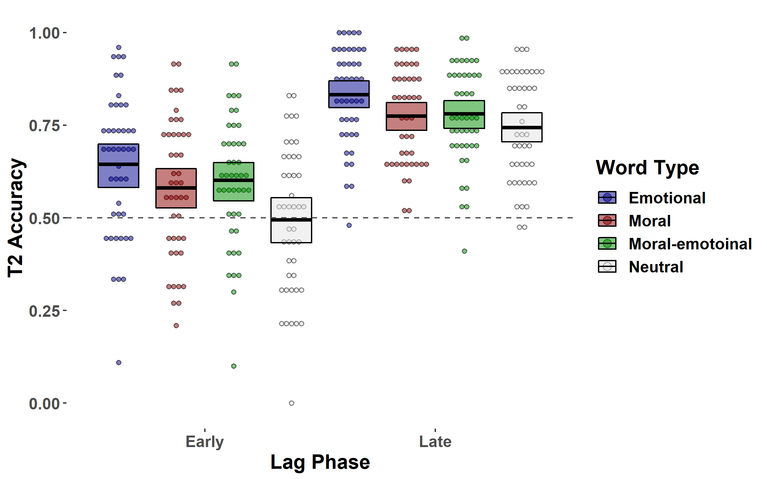

**Fig. 2. T2 accuracy as a function of lag and word type.** Distinctly moral, distinctly emotional and moral-emotional word categories showed a significant reduction in the attention blink compared to neutral words, suggesting that they capture attention to a greater extent than neutral words. For visualization, the graph displays mean accuracies for each T2 word category for each participant, however data were analyzed with each trial as an observation. The horizontal dotted line represents mean accuracy of 50% which represents incorrect word identification on half of the trials.

Next, we directly compared T2 accuracies among distinctly moral, distinctly emotional, and moral-emotional T2 words. We found no significant differences between moral-emotional words and emotional T2 word accuracy, OR = 0.88, *p* = .189, 95% CI = [0.72, 1.07], or moral-emotional vs. distinctly moral T2 accuracy, OR = 0.90, *p* = .297, 95% CI = [0.74, 1.09], but we found that distinctly moral T2 words attracted less attention than distinctly emotional words, OR = 0.79, *p* = .018, 95% CI = [0.65, 0.96]. Thus, while moral language draws more attention than neutral content (see also Gantman & Van Bavel, 2014), it may garner even more attentional capture when emotional language is involved. Furthermore, it does not appear that moral language and emotional language produce additive increases in attentional capture.

*Exploratory arousal analysis*. Emotional expression with or without moral expression appeared to exhibit similar abilities to capture attention, raising the possibility that some other process could explain attentional capture of the words besides our theoretically-derived categories . For example, *valence* and *arousal* are fundamental dimensions on which different emotions can be categorized (Russell & Barrett, 1999). Previous studies have found that the extent to which emotional words are arousing, rather than their valence, explains variation in attentional capture (Anderson, 2005). Thus, we tested the extent to which words are arousing could explain variance in T2 accuracy across our word categories.

To this end, we pulled human-coded arousal ratings for the T2 words used in our study from a database of 13,915 word ratings (the ‘extended ANEW’ set; Warriner, Kuperman, & Brysbaert, 2013). Using this method, we obtained normative arousal ratings for 107 of our 112 T2 words (see SI Appendix, Section 1). We then ran a similar multilevel model from our main analysis above but replaced word type with arousal rating (see SI Appendix, Table S9 for model details). Results revealed a small but significant main effect of arousal across all word categories on T2 accuracy, OR = 1.06, *p* = .020, 95% CI = [1.01, 1.12]. However, when word type and arousal were modeled together the effect of arousal was not statistically significant, OR = 0.97, *p* = .201, 95% CI = [0.92, 1.02], while the effects of word type remained significant for distinctly moral (OR = 1.38, *p* <.001, 95% CI = [1.19, 1.60]), distinctly emotional (OR = 1.96, *p* <.001, 95% CI = [1.66, 2.32]) and moral-emotional (OR = 1.61, *p* <.001, 95% CI = [1.37, 1.89]) words (see SI Appendix, Table S10 for model details). Model comparison tests also revealed that this model, which statistically adjusted for the effects of word type, was a significantly better fit of the data than the model with arousal as the sole predictor (see SI Appendix, Section 1 for details). These results suggest that our theoretically-derived word category distinctions explain unique variance in attentional capture beyond the arousal-level of each word.

Study 2: Attentional capture in an ecologically valid blink task

We sought to replicate our finding that moral and emotional words capture more attention than neutral words in a more ecologically valid context. Although the attentional blink task has some striking similarities to the way people engage with social media (e.g., it presents a sequence of verbal content) it is nevertheless a modest substitute for real social media environments where users perceive words embedded in full messages (e.g., in the form of a Tweet or a status update as they scroll through their feed). In Study 2 we created a novel version of the attentional blink paradigm that more accurately simulates the experience of using social media. We presented people with a sequence of Tweets to simulate the experience of scrolling through their Twitter feed—an experience that over 335 million people engage in every month (Statistica, 2018). Including full tweets also tested whether the attentional capture effects from Study 1 generalize to full messages.

## **Method**

*Participants*. Fifty-six undergraduate students at New York University (38 females; *M*age = 19.54, *SDage* = 1.57) participated for course credit. We intended to collect 50 participants based on the power analysis used in Study 1 but continued collecting data until the end of the semester anticipating the need to drop participants due to floor accuracy as in Study 1. This collection decision ultimately resulted in 56 participants. Three participants were removed from the data set due to mean accuracy under 25% in the early lag phase, leaving a final sample size of 53. However, the reported results are consistent when these participants remain in the data set (see SI Appendix, Section 2).

*Procedure*. We employed the same procedure as in Study 1, with the exception that the stimuli and presentation timing were altered. Rather than present individual words, each trial consisted of 15 different fake Twitter messages that expressed pro-gun control attitudes (13 ‘distractors’ and 2 targets) were displayed for 110 ms at a time. The stimulus presentation time was increased slightly from Study 1 since the stimuli were full messages. Pilot testing revealed accuracies under 25% when the stimuli were presented at 100ms, and the 10ms adjustment raised mean accuracies (across all T2 categories) to levels near Study 1. We choose to present messages with traditionally liberal attitudes since the large majority of NYU undergraduate students are liberal, especially with regards to gun control.

*Stimuli*. Each short message consisted of 2 lines of text (9 total words) expressing a pro-gun control attitude, and ended with one #hashtag word (e.g., #kill) alone on a third line. Distractor stimuli were messages with neutral hashtags that were black in color. T1 and T2 messages consisted of a blue-colored hashtag designed to mimic the hue of Twitter’s hashtag designation (see Fig. 3). T2 hashtags were manipulated to contain one of four word types (distinctly moral, distinctly emotional, moral-emotional, and neutral). The same T2 words from Study 1 were used for each word type. We selected a combination of neutral words from Study 1 and new neutral words that were matched on confounding dimensions as in Study 1 to ensure that the effects found in Study 1 were not an artifact of specific neutral words since its category is relatively large.

The position in which T1 appeared was again jittered to avoid anticipation, and T2 appeared between 1 to 7 “lags” after T1 (see Fig. 3). Participants completed 224 trials consisting of 56 trials for each of four possible T2 word categories. Within the 56 trials of each word type, there were 2 trials per lag phase (1-7). Within each category, words were assigned to each lag phase randomly, and trials were presented in randomized order. Participants were offered an optional 1-minute break halfway through the experiment. Example stimuli are presented in Fig 3. All stimuli are available at <https://osf.io/z6evq/>

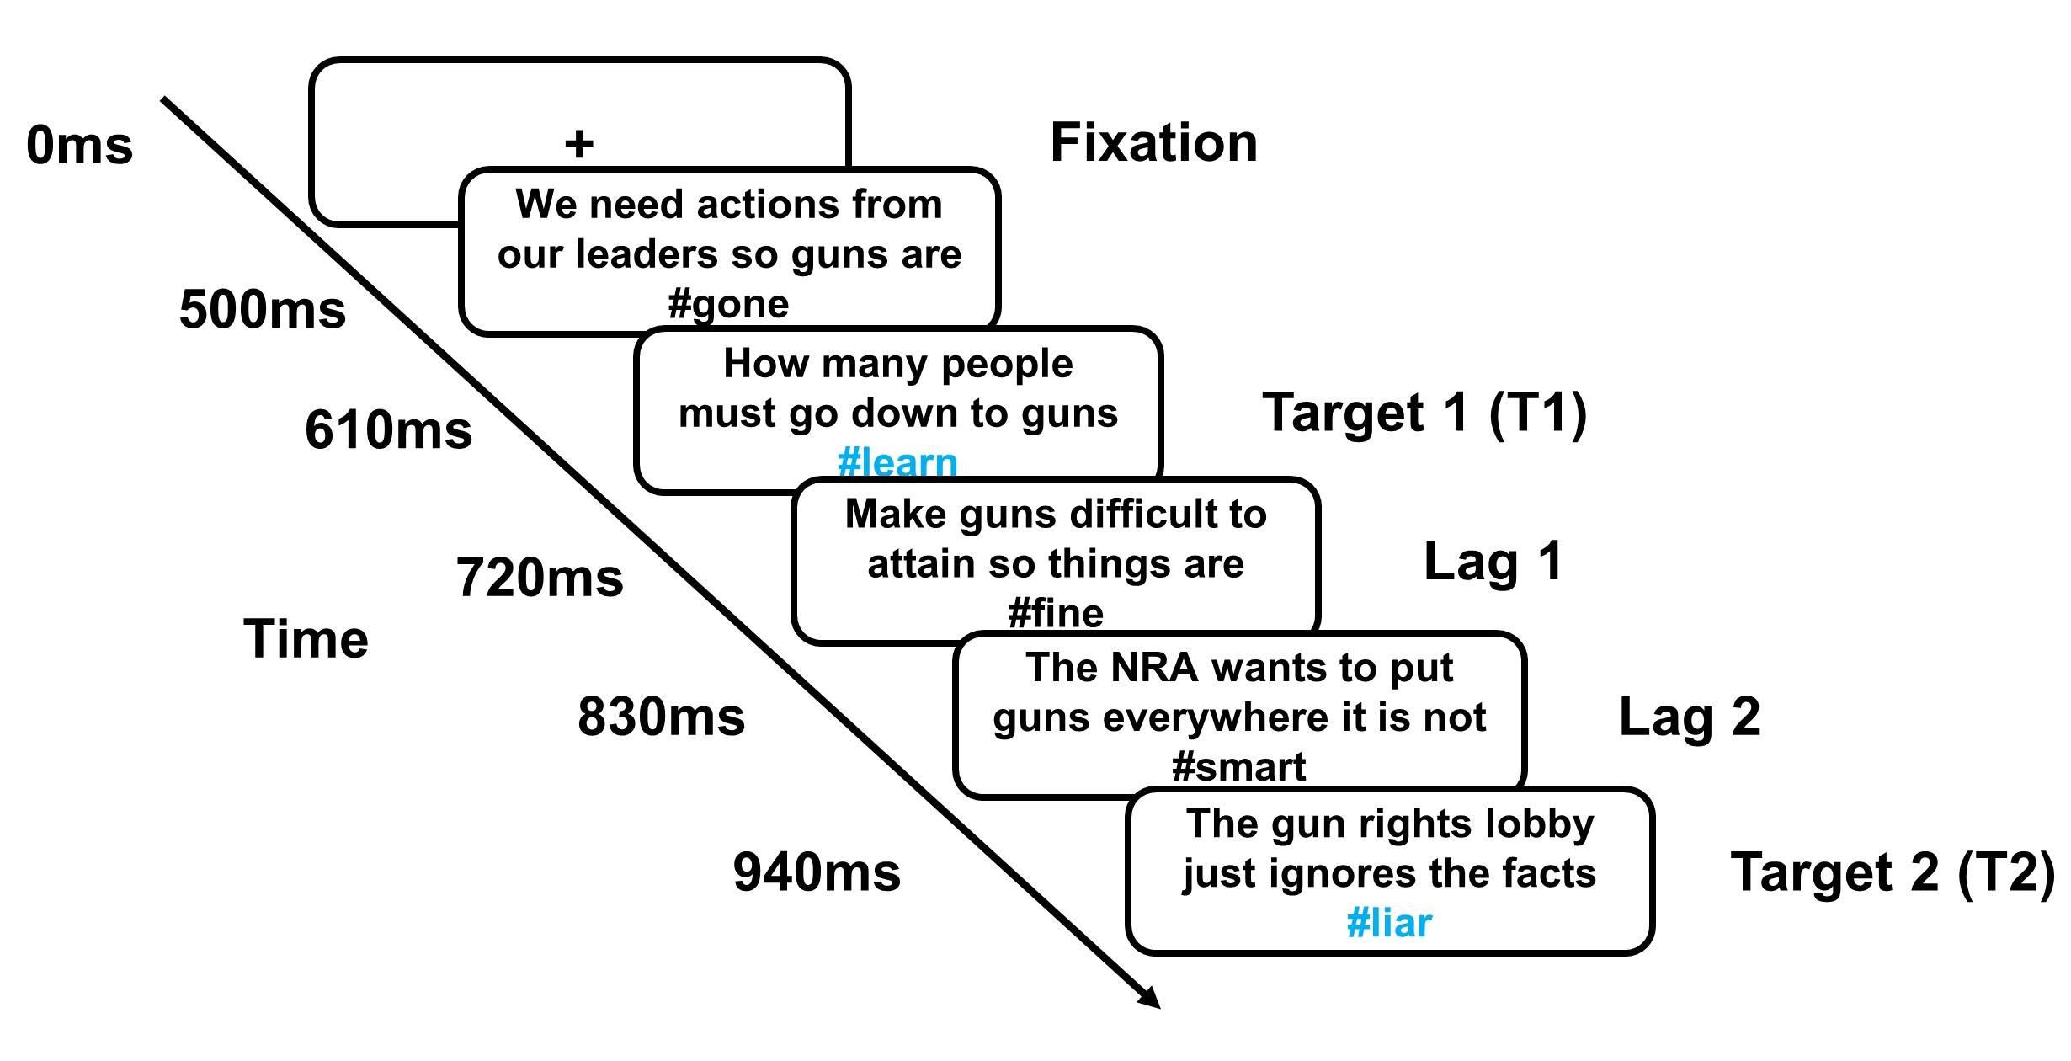

**Fig. 3. Social media attentional blink paradigm.** Participants viewed rapidly presented words in 110ms intervals. Their task was to identify two target words that appeared as a hashtag in blue. The first target (T1) appeared at a jittered position 500-830ms after fixation. The second target (T2) appeared 1-7 words after T1, represented as the “lag” position (e.g., Lag 1). This figure depicts a trial where T2 appears at Lag 3. For each trial, the T2 hashtag was a word from one of four types: distinctly moral, distinctly emotional, moral-emotional, and neutral. Images are not shown to scale.

## **Results**

*Data preprocessing.* As in Study 1, all trials for which participants did not correctly identify T1 were dropped. Lag phase was again collapsed to a binary variable where lags 1-3 were coded as “early lag” and lags 4-7 were coded as “late lag” (Anderson & Phelps, 2001), but results remained consistent when lag phase was modeled continuously (see SI Appendix, Section 2). Word category was treated as a categorical variable with 4 levels (distinctly moral, distinctly emotional, moral-emotional, neutral) and therefore was entered into the regression model as 3 dummy-coded variables where the reference level was not entered. T2 accuracy was treated as a binary variable where 1 = correct word identification and 0 = incorrect word identification.

*Main Analyses.* In order to test whether the attentional blink was reduced as a function of the word type of T2, we regressed T2 accuracy on word type, lag phase, and their interaction using each trial as an observation. To account for correlation in variance among stimuli and participants, we again employed a multi-level model with trials nested within stimuli, and stimuli nested within participants using generalized estimating equations (GEE; Hardin, 2005) with robust standard error estimation and an exchangeable correlation structure.

Replicating the results of Study 1, there was a significant main effect of lag, odds-ratio (OR) = 2.62, *p* < .001, 95% CI = [2.22, 3.09], such that participants were 2.56x more accurate in late lags compared to early lags. Replicating Study 1, there were significant effects of all T2 word types compared to neutral words. Participants were 1.64x more likely to correctly identify a distinctly moral T2 word compared to a neutral T2 word, OR = 1.64, *p* <.001, 95% CI = [1.37, 1.96], 1.93x more likely to correctly identity a distinctly emotional T2 word compare to a neutral T2 word, OR = 1.85, *p* <.001, 95% CI = [1.61, 2.32], and 1.66x more likely to identify a moral-emotional T2 word compared to a neutral T2 word, OR = 1.66, *p* <.001, 95% CI = [1.39, 1.99]. These differences in T2 accuracy between the moral / emotional words and neutral words did not vary as a function of lag phase (see SI Appendix, Section 2 for details). Modeling lag phase continuously did not change any statistical conclusions. Distinctly moral (OR = 1.47, *p* <.001, 95% CI = [1.23, 1.68]), distinctly emotional (OR = 1.91, *p* <.001, 95% CI = [1.66, 2.20]), and moral-emotional (OR = 1.65, *p* <.001, 95% CI = [1.44, 1.89]) words all showed a significant reduced attentional blink effect compared to the neutral T2 category when adjusting for continuous lag phase, demonstrating greater attentional capture (for model details see SI Appendix, Table S15). These findings replicate those of Study 1 and suggest that messages that include words related to both morality and emotion are prioritized in visual attention to a greater extent than messages with neutral words (See Fig. 4).

We found one statistical trend but no significant differences when comparing any of the other categories to each other: distinctly emotional vs. distinctly moral, OR = 1.18, *p* = .087, 95% CI = [0.98, 1.42], distinctly emotional vs. moral-emotional, OR = 1.16, *p* = .113, 95% CI = [0.97, 1.40], nor moral-emotional vs. distinctly moral, OR = 1.01, *p* = .898, 95% CI = [0.84, 1.22]. Similar to Study 1, moral-emotional and emotional words did not show significantly different T2 accuracies, and the distinctly emotional words did show greater T2 accuracies than distinctly moral words (but it was only marginally significant in this study). These data suggest that both moral and emotional content draw more attention than neutral content, but likely do so with similar efficacy relative to one another.

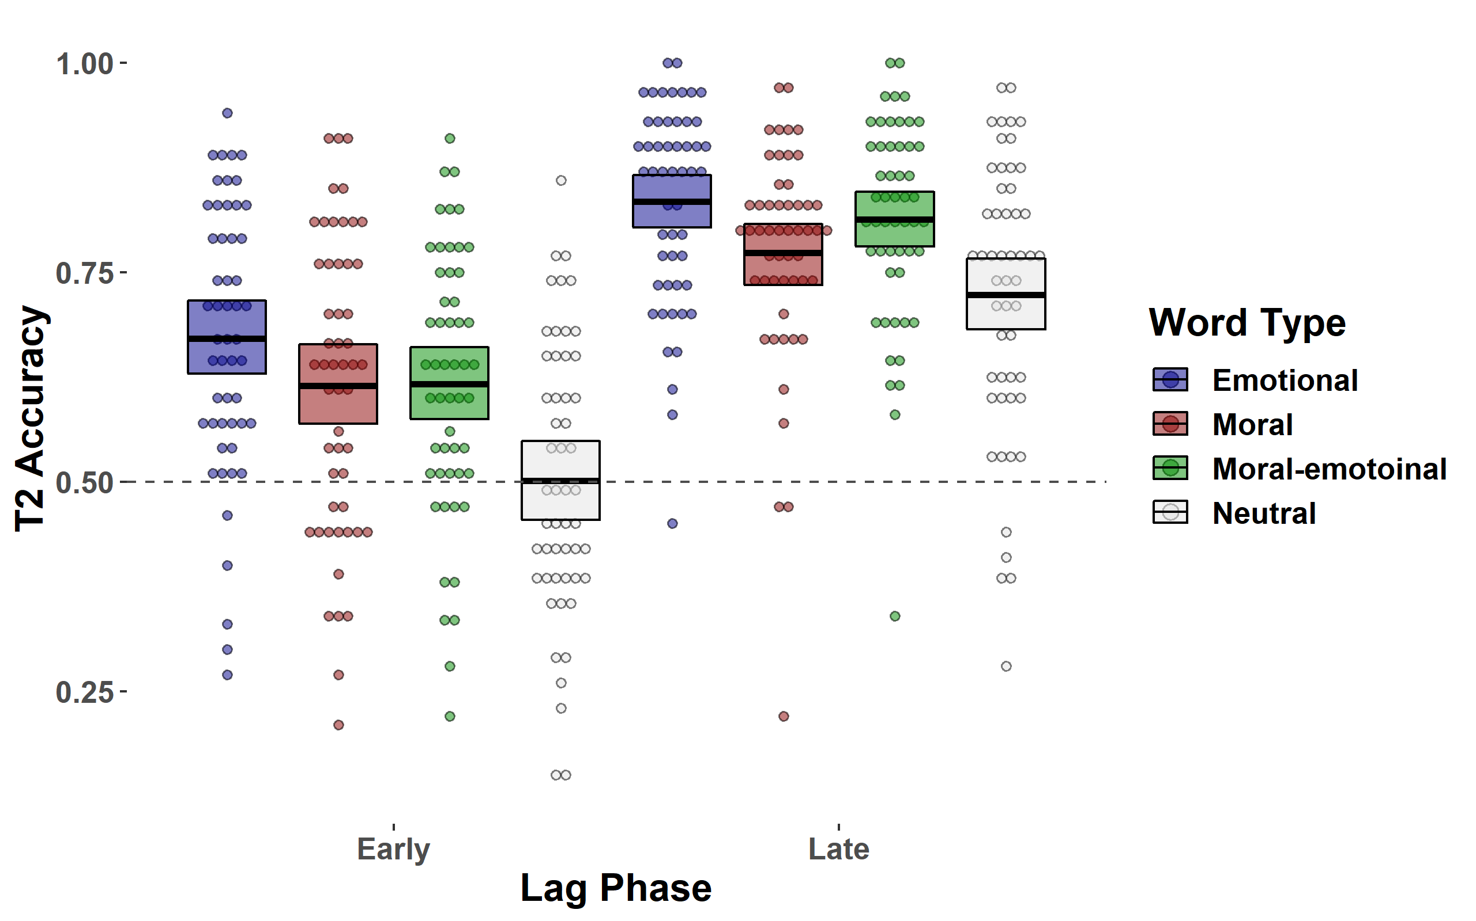

**Fig. 4. T2 accuracy as a function of lag and word type.** Distinctly moral, distinctly emotional and moral- emotional word categories showed a significant reduction in the attention blink compared to neutral words, suggesting that they capture attention to a greater extent than neutral words. For visualization, the graph displays mean accuracies for each T2 word category for each participant, however data were analyzed with each trial as an observation. The horizontal dotted line represents mean accuracy of 50% which represents incorrect word identification on half of the trials.

*Exploratory**arousal analysis*. As in Study 1, we explored whether the extent to which words are arousing could explain variance in T2 accuracy even across word types (see SI Appendix, Section 1). Replicating Study 1, results revealed a significant main effect of arousal across all word categories on T2 accuracy, OR = 1.07, *p* = .009, 95% CI = [1.02, 1.14], but once again this effect did not remain significant when statistically adjusting for the effect of word category, OR = 0.97, *p* = .311, 95% CI = [0.91, 1.03]. In this model, the effects of distinctly moral (OR = 1.37, *p* <.001, 95% CI = [1.18, 1.58]), distinctly emotional (OR = 1.94, *p* <.001, 95% CI = [1.65, 2.27]) and moral-emotional (OR = 1.61, *p* <.001, 95% CI = [1.36, 1.91]) words all remained statistically significant (see SI Appendix, Tables S16-17 for model details). Thus, again arousal could not fully account for the differences in attentional capture among moral and emotional word categories. In sum, Study 2 replicated the key results of Study 1 using stimuli that better simulated real social media experience. Furthermore, attentional capture differences among moral and emotional language cannot be fully explained by arousal.

Study 3: Attentional capture is associated with online sharing

Studies 1 and 2 used tightly controlled experiments with increasing ecological validity, and we observed clear evidence that moral and emotional language alone and together capture attention to a greater extent than neutral language—even for a measure of attention designed to better mimic social media environments. The purpose of Study 3 was to evaluate whether there is a measurable connection between attention to moral and emotional words in the lab and retweet behavior during real moral and political social media communications. To our knowledge, this study is the first attempt to connect data from the attentional blink paradigm in the lab to behavior in online social networks. Social media is a particularly important context to study moral and emotional messages since recent work suggests that social media is now the primary source of moral outrage for most people (Crockett, 2017) and there is reason to believe that such content can have aversive consequences (Brady & Crockett, 2018).

## **Method**

We analyzed a large dataset containing Twitter conversations about contentious political topics of gun control, same-sex marriage and climate change (*N* = 563,312; Brady et al., 2017). We explored whether attentional capture of individual words measured in a controlled lab setting lab would correlate with real sharing behavior (i.e., retweeting) of these Twitter messages. Insofar as attentional capture plays a role in the increased engagement garnered by moral and emotional content, and in social media engagement more generally, we expected that there would be a positive relationship between T2 accuracies for a given word and the extent to which messages containing those words are retweeted.

To determine each word’s attentional capture score based on lab data, we first computed the mean of a word’s accuracy across trials within a participant, defined as the number of correct identifications out of the total trials the word appeared (including all lag phases). Scores could therefore range from 0 to 100% accuracy. Using this score for each word and each participant, we then computed the mean across all participants. Thus, every T2 word in our study was assigned a mean accuracy score that represented the mean accuracy level for a word across participants in the study. The mean accuracies for each word from Study 1 and Study 2 were averaged for words that appeared in both studies (neutral words were varied in Study 2 and thus could not be averaged across both studies).

In order to associate mean T2 word accuracies with Twitter data, we used all topic data sets from Brady et al. (2017), which contains 563,312 combined original tweets and retweets about contentious political topics including gun control, same-sex marriage, and climate change. We searched for the presence of the 120 words from each word type category appearing as T2 in Studies 1 and 2 in the database of tweets. To do so, each tweet was tokenized and words used as T2 in Studies 1 and 2 were matched using the *R* package *tidytext* v. 0.1.8 (Silge & Robinson, 2016), thus assigning an attention capture value from the lab to any of the T2 words present in tweets. Because we only had attentional capture values for the 120 words appearing in our lab studies, we trimmed the dataset so it only contained tweets that had at least one of the 120 words in it, leaving a final sample of 47,552 original tweets.

Each tweet was then assigned one “attentional capture index” that represented the sum of the mean attention capture values for every word of the 120 that could have appeared in it. For instance, consider the following tweet: “Shame on President Trump for his abuse of power”. This tweet contains two T2 words from our study: “shame” and “abuse”. If the mean attentional capture score from the lab for ‘shame’ was .80 and for ‘abuse’ was .70, then the tweet would be assigned an attentional capture index value of 1.5. For cross-validation purposes, we also tested a model that formed an attentional capture index value by taking the *mean* attentional capture score of T2 words in a tweet rather than the sum. Results reported below remained consistent regardless of which specific formulation of the attentional capture index was used (see SI Appendix, Section 3 for more details). The *R* script for the method described above is available at <https://osf.io/z6evq/>.

## **Results**

We examined the relationship between attentional capture of words as measured in the lab and retweet counts for those same words within messages on social media. We regressed the retweet count (the primary method of sharing on Twitter) of each tweet on the attentional capture index of each tweet using a negative binomial model (Hilbe, 2011) to account for overdispersion present for the retweet count variable. We confirmed the suitability of modeling the retweet counts using a negative binomial model by examining the distribution and formally testing differences in model fit compared to other count models (e.g., Poisson; see R script for Study 3, line 58, available at <https://osf.io/z6evq/>). This model revealed a positive, significant effect of attentional capture index on retweet count, Incident Rate Ratio (IRR) = 1.38, *p* <.001, 95% CI = [1.26, 1.52] (see Fig. 5). In other words, tweets with a greater attention capture value (as assessed by specific words in the tweet) were associated with greater expected retweet counts. We explored whether a quadratic trend was also present in the relationship between attentional capture and retweeting, but this effect was not significant, IRR = 0.87, p = .073, 95% CI = [0.75, 1.01]. In this model the linear effect still remained significant, IRR = 1.54, p <.001, 95% CI = [1.32, 1.80]. Details for the model testing a quadratic effect are presented in Table S19. The results of our analyses provide novel evidence that attentional capture helps explain the increased ability for moral and emotional content to go viral on social media.

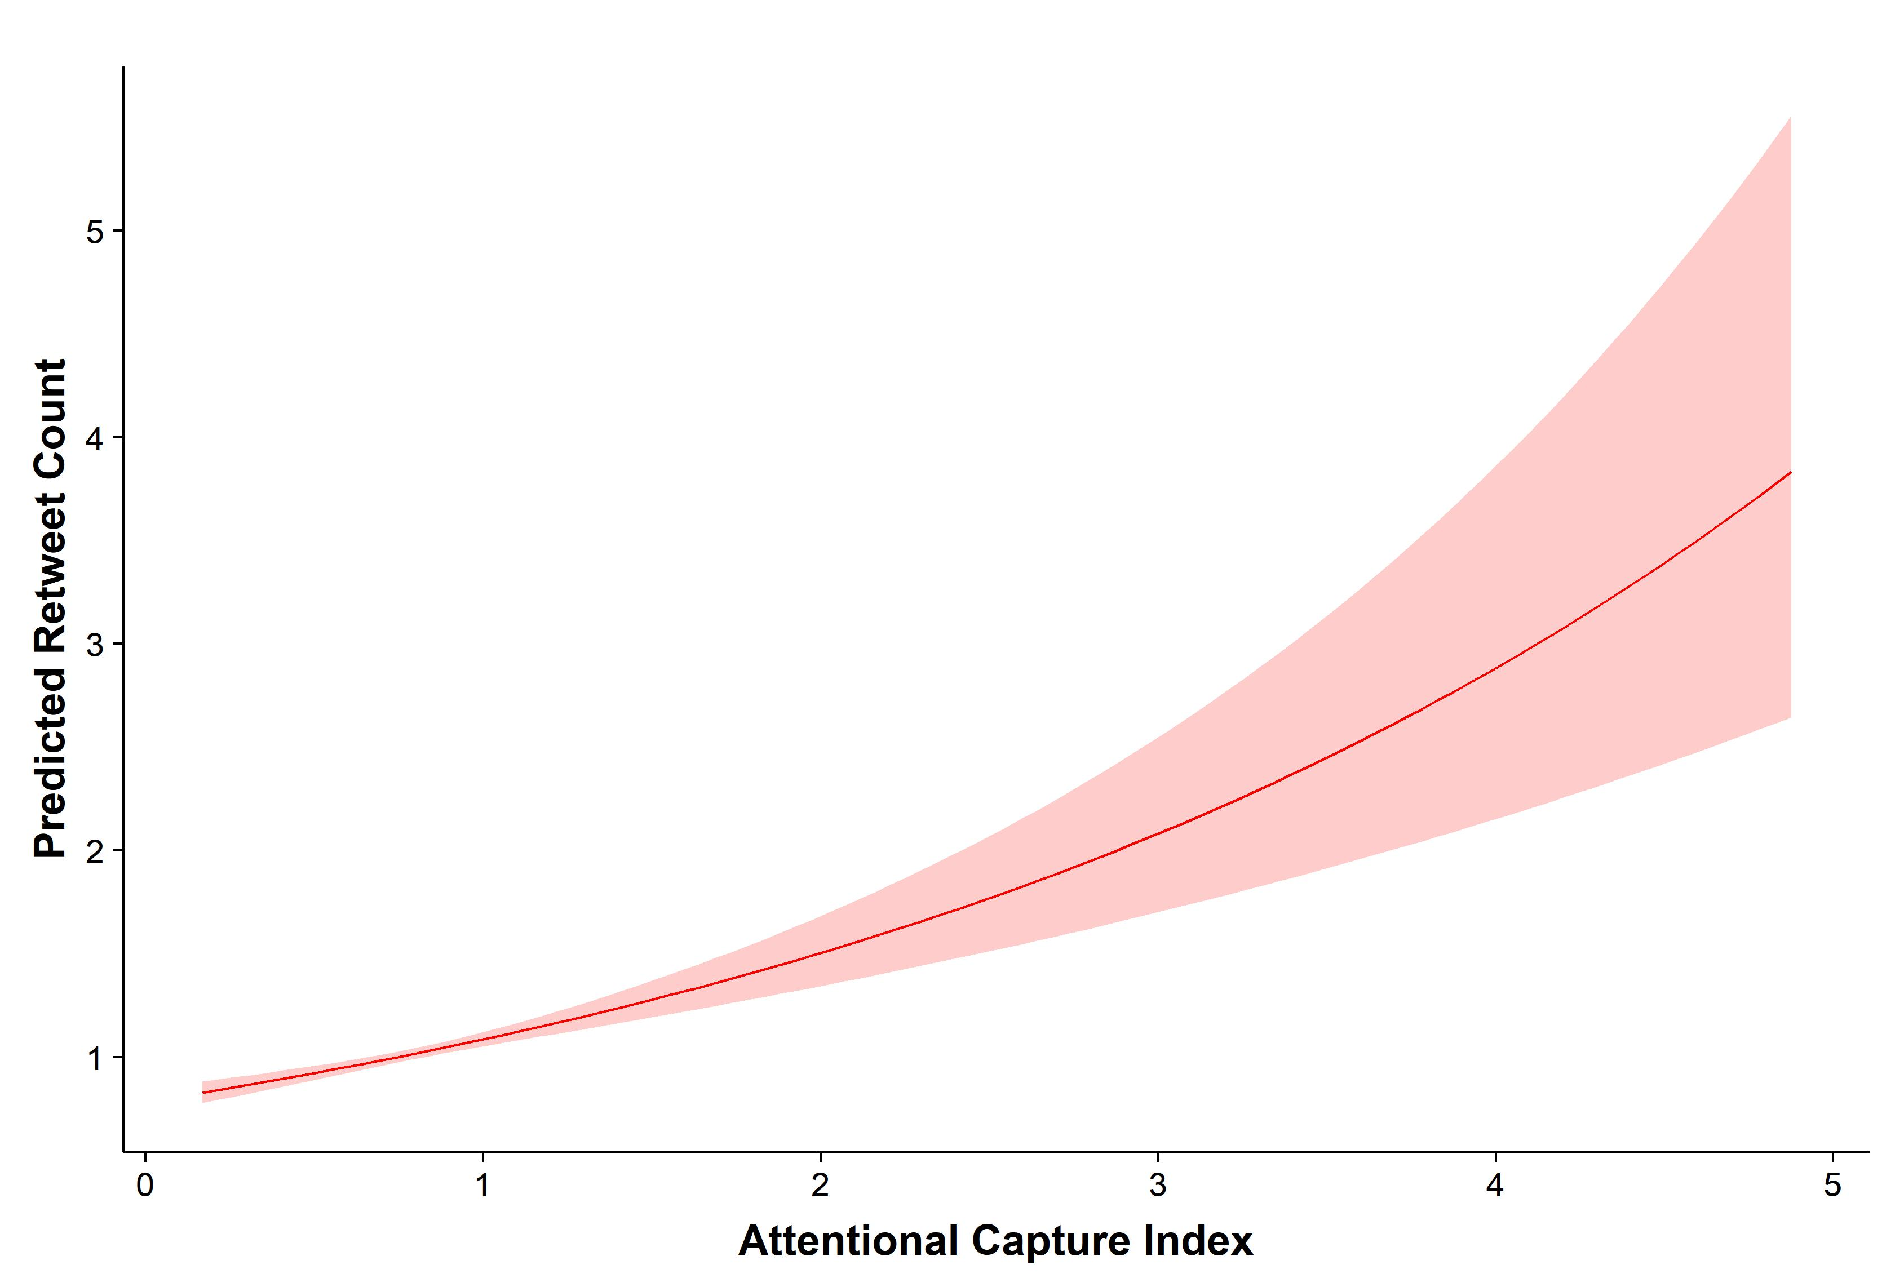

**Fig. 5. Retweet count as a function of attentional capture index.** Tweets with greater attention capture value of as assessed by specific words in the tweet were associated with greater expected retweet counts. Attentional capture index was calculated based on the mean attentional capture data from our lab study for each T2 word present in a tweet.

General Discussion

Overall, we find that moral and emotional language capture attention to a greater extent than neutral language, and that this may partly explain why messages using this language are more likely to be shared on social media. Two lab experiments using both traditional and novel methods provided strong evidence that moral and emotional language captures attention to a greater extent than neutral language. This conceptually replicates previous work demonstrating prioritized visual processing for emotional (Anderson & Phelps, 2001; Anderson, 2005; Keil & Ihssen, 2004), as well as moral stimuli (Gantman & Van Bavel, 2014). We also provided one of the first attempts to link attention capture as measured in the lab to real behavior on Twitter and found evidence that attentional capture is associated with retweet behavior in the context of online moral and political discourse. Our findings suggest that attentional capture may in part explain the advantage that moral and emotional content have over neutral content in drawing engagement on social media (Brady et al., 2017; Stieglitz & Dang-Xuan, 2013; Valenzuela et al., 2017).

This work also provided one of the first direct tests of whether moral versus emotional content is prioritized in rapid visual processing. Our results suggest that moral and emotional content are both prioritized, but are prioritized somewhat equally in comparison (if anything, emotional content may have a slight advantage). There may be a general threshold for an attentional advantage that can be surpassed by any motivationally relevant content that is moral, emotional, or both. However, the decision to share content in the context of political communications does not appear to be fully explained by attentional capture. For instance, while moral-emotional content was more consistently associated with increased engagement than distinctly moral and emotional content (Brady, Wills, Burkart, Jost, & Van Bavel, 2018; Brady et al., 2017), we found no evidence that moral-emotional content generates an attentional advantage over purely moral or emotional content. Future research should investigate other basic cognitive and social processes that could explain the specific engagement advantage enjoyed by moral-emotional content including enhanced memory for moral and emotional content (Phelps, 2004), top-down effects of morality on perception (Gantman & Van Bavel, 2015; Van Bavel, FeldmanHall, & Mende-Siedlecki, 2015), or other social psychological processes such as the importance of moral identity (Aquino & Reed, 2002), and social identity concerns more broadly (Tajfel & Turner, 1986). Furthermore, moral and emotional language might be perceived by others as more diagnostic of their opinions, rendering a point more persuasive, or more urgent than other content, and this may also lead to greater retweet rates. There are undoubtedly multiple factors that go into a decision to retweet, and our results suggest that attentional capture is one such factor (see also Brady, Crockett, & Van Bavel, 2019).

While Studies 1 and 2 demonstrate that the morality and emotionality of words appear to play a causal role increasing attentional capture, Study 3 was only able to establish a correlation between attentional capture and online sharing. This study makes a direct connection between carefully-controlled laboratory experiments and ecologically rich behavior online. Nevertheless, because we did not manipulate the content on Twitter, this raises the possibility for an alternative explanation of Study 3 results: increased sharing might increase the attentional capture potential of moral and emotional content. This explanation is indirectly supported by studies suggesting that people engage with content more once they observe it is popular (i.e., when other people have already engaged with it; Salganik, Dodds, & Watts, 2006). Most likely, attention and online sharing affect one another to produce a relationship that resembles a feedback loop, such that more attention leads to more sharing, and more sharing leads to more attention. Additionally***,*** this may help explain why the relationship between attention and online sharing observed in Study 3 appears to accelerate as attentional capture increases. Future work that either manipulates attention to Twitter messages in the lab or directly on Twitter is required in order to fully clarify the precise causal relationship between attentional capture and online sharing. For instance, previous work has shown moral decisions can be influenced when attention to possible choices is manipulated (Pärnamets et al., 2015). We reiterate that sharing behavior online is a multiply-determined process, and attentional capture is one of many factors that might play an important role. Future work can confirm the conditions under which attention is important, and conditions under which other factors, like those listed above, elicits online sharing behavior.

The results presented here also have implications for impression formation as it unfolds on social media. Particularly in the realm of political conversations, our data suggest that communication highlighting moral and emotional content can increase attentional capture and possibly lead to greater engagement. If impression formation is dominated by perceptions of moral character (Brambilla & Leach, 2014; Goodwin, 2015), political leaders and partisans can use morally-framed conversations on social media to drive attention to their “good” character and make it salient over and above other information about them (see Brady et al., 2019). Future research should examine the conditions under which social media facilitates or creates barriers to judgment of people’s moral character (e.g., the extent to which social cues are limited; Tanis & Postmes, 2003).  
 We also found that the arousal level of a word could not fully explain our findings. This raises the possibility that another psychological process explains variance in attentional prioritization between moral and non-moral emotional stimuli. The explanation may lie in social psychological explanations of the theoretical and functional differentiation of moral vs. non-moral emotions (Haidt, 2003; Hutcherson & Gross, 2011; Scherer, 2001). For example, even though moral and non-moral emotional stimuli may be similarly arousing, they could have differential effects regarding attentional capture in specific contexts that differ in terms of motivational relevance. For example, in contexts where one observes specific norm violations, moral-emotional stimuli such as outrage expression are especially relevant (see e.g., Fiske & Tetlock, 1997; Salerno & Peter-Hagene, 2013), and may be prioritized in attention compared to non-moral emotional stimuli. Although arousal may generally increase sharing of content such as news articles online (Berger & Milkman, 2012), our work suggests that the role of attentional capture in the sharing of moral and emotional content online cannot be explained exclusively by the extent to which the content is arousing.

Although we used a relatively large set of stimuli, this is merely a sample of the large range of possible moral and emotional stimuli that people encounter in their daily lives. Thus, the present results are limited to the relatively small selection of words that were used for maximal control in our studies. We also compared undergraduate students’ attentional capture performance to sharing behavior of active Twitter users, which may have consequences for estimation of our effects. For example, this likely led us to underestimate how large the effect of attention capture is on sharing behavior: Twitter users who engage in political discussion may be more ideologically extreme than the average undergraduate student, and therefore moral and emotional content may be even more motivationally relevant for them compared to undergraduates. Future research should investigate a larger, more representative sample of words and sample a wider of range of demographics to under to better determine how well our results generalize to all moral and emotional content and all demographics. Furthermore, future research could measure attention and sharing behavior within a single context to draw a more direct test of the relationship between attentional capture and sharing behavior. Finally, our ‘social media attentional blink’ task in Study 2 used political messages that were liberal-learning due to our sample of university students. Future work should test whether results generalize to content expressing political views of both ideologies and from participants with varying ideologies, especially given that there is evidence of conservative-liberal asymmetry in the spread of moralized content online (Brady et al., 2018).

Conclusion

In three studies using tightly-controlled lab experiments with increasing ecological validity and linking these data to real Twitter communications, we found that (1) moral and emotional language both capture attention to a greater extent than neutral language, and (2) such attentional capture potential in words is associated with real-world patterns of retweeting on Twitter. These data shed light on the cognitive underpinnings of the spread of moralized content online, which can help explain how political leaders, disinformation profiteers, marketers, and online activist organizations can spread content by capitalizing on natural tendencies of our perceptual systems.

References

Anderson, A. K. (2005). Affective influences on the attentional dynamics supporting awareness. *Journal of Experimental Psychology: General*, *134*(2), 258–281.

Anderson, A. K., & Phelps, E. A. (2001). Lesions of the human amygdala impair enhanced perception of emotionally salient events. *Nature*, *411*(6835), 305–309.

Aquino, K., & Reed, A. (2002). The self-importance of moral identity. *Journal of Personality and Social Psychology*, *83*(6), 1423–1440.

Arnell, K. M., Killman, K. V., & Fijavz, D. (2007). Blinded by Emotion: Target Misses Follow Attention Capture by Arousing Distractors in RSVP. *Emotion*.

Baumert, A., Gollwitzer, M., Staubach, M., & Schmitt, M. (2011). Justice sensitivity and the processing of justice-related information. *European Journal of Personality*.

Berger, J., & Milkman, K. L. (2012). What makes online content viral? *Journal of Marketing Research*, *49*(2), 192–205.

Brady, W. J., & Crockett, M. J. (2018). How effective is online outrage? *Trends in Cognitive Sciences*.

Brady, W. J., Crockett, M. J., & Van Bavel, J. J. (2019). The MAD Model of Moral Contagion: The role of motivation, attention and design in the spread of moralized content online.

Brady, W. J., Wills, J. A., Burkart, D., Jost, J. T., & Van Bavel, J. J. (2018). An ideological assymetry in the diffusion of moralized content on social media among political elites. *Journal of Experimental Psychology: General*.

Brady, W. J., Wills, J. A., Jost, J. T., Tucker, J. A., & Van Bavel, J. J. (2017). Emotion shapes the diffusion of moralized content in social networks. *Proceedings of the National Academy of Sciences*, *114*(28), 7313–7318.

Brambilla, M., & Leach, C. W. (2014). On the Importance of Being Moral: The Distinctive Role of Morality in Social Judgment. *Social Cognition*, *32*(4), 397–408.

Brosch, T., & Van Bavel, J. J. (2012). The flexibility of emotional attention: Accessible social identities guide rapid attentional orienting. *Cognition*, *125*(2), 309–316.

Campos, J. J., Mumme, D. L., Kermoian, R., & Campos, R. G. (1994). A functionalist perspective on the nature of emotion. *Monographs of the Society for Research in Child Development*.

Ciesielski, B. G., Armstrong, T., Zald, D. H., & Olatunji, B. O. (2010). Emotion modulation of visual attention: Categorical and temporal characteristics. *PLoS ONE*.

Crockett, M. J. (2017). Moral outrage in the digital age. *Nature Human Behaviour*, *1*(11), 769–771.

Dijksterhuis, A., & Aarts, H. (2010). Goals, Attention, and (Un)Consciousness. *Annual Review of Psychology*.

Fiske, A. P., & Tetlock, P. E. (1997). Taboo Trade-offs: Reactions to Transactions That Transgress the Spheres of Justice. *Political Psychology*, *18*(2), 255–297.

Gantman, A. P., & Van Bavel, J. J. (2014). The moral pop-out effect: enhanced perceptual awareness of morally relevant stimuli. *Cognition*, *132*(1), 22–29.

Gantman, A. P., & Van Bavel, J. J. (2015). Moral Perception. *Trends in Cognitive Sciences*, *19*(11), 631–633.

Goodwin, G. P. (2015). Moral Character in Person Perception. *Current Directions in Psychological Science*, *24*(1), 38–44.

Goodwin, G. P., Piazza, J., & Rozin, P. (2014). Moral character predominates in person perception and evaluation. *Journal of Personality and Social Psychology*, *106*(1), 148–168.

Haidt, J. (2003). The moral emotions. In R. J. Davidson, K. R. Scherer, & H. H. Goldsmith (Eds.), *Handbook of affective sciences* (pp. 572–595). New York, NY: Oxford University Press.

Haidt, J. (2012). *The righteous mind: Why good people are divided by politics and religion*. Vintage.

Hardin, J. W. (2005). Generalized estimating equations (GEE). In B. Everitt & D. Howell (Eds.). Hoboken, NJ: Wiley Online Library.

Hilbe, J. M. (2011). Negative Binomial Regression. *Public Administration Review*, *70*, 1–6.

Hutcherson, C., & Gross, J. (2011). The moral emotions: A social–functionalist account of anger, disgust, and contempt. *Journal of Personality and Social …*, *100*(4), 719–737.

Jost, J. T., Barberá, P., Bonneau, R., Langer, M., Metzger, M., Nagler, J., … Tucker, J. A. (2018). How Social Media Facilitates Political Protest: Information, Motivation, and Social Networks. *Political Psychology*, *39*, 85–118.

Keil, A., & Ihssen, N. (2004). Identification Facilitation for Emotionally Arousing Verbs during the Attentional Blink. *Emotion*, *4*(1), 23–35.

Lerner, M. J., & Miller, D. T. (1978). Just world research and the attribution process: Looking back and ahead. *Psychological Bulletin*, *85*(5), 1030–1051.

Milders, M., Sahraie, A., Logan, S., & Donnellon, N. (2006). Awareness of faces is modulated by their emotional meaning. *Emotion*, *6*(1), 10–17.

Most, S. B., Smith, S. D., Cooter, A. B., Levy, B. N., & Zald, D. H. (2007). The naked truth: Positive, arousing distractors impair rapid target perception. *Cognition and Emotion*.

Most, S. B., & Wang, L. (2011). Dissociating spatial attention and awareness in emotion-induced blindness. *Psychological Science*.

Ohman, A., Flykt, A., & Esteves, F. (2001). Emotion drives attention: detecting the snake in the grass. *Journal of Experimental Psychology: General*, *130*(3), 466–478.

Öhman, A., & Mineka, S. (2001). Fears, phobias, and preparedness: Toward an evolved module of fear and fear learning. *Psychological Review*, *108*(3), 483–522.

Pärnamets, P., Johansson, P., Hall, L., Balkenius, C., Spivey, M. J., & Richardson, D. C. (2015). Biasing moral decisions by exploiting the dynamics of eye gaze. *Proceedings of the National Academy of Sciences*, *112*(13), 4170–4175.

Phelps, E. A. (2004). Human emotion and memory: Interactions of the amygdala and hippocampal complex. *Current Opinion in Neurobiology*.

Phelps, E. A., Ling, S., & Carrasco, M. (2006). Emotion facilitates perception and potentiates the perceptual benefits of attention. *Psychological Science*, *17*(4), 292–299.

Raymond, J. E., Shapiro, K. L., & Arnell, K. M. (1992). Temporary Suppression of Visual Processing in an RSVP Task: An Attentional Blink? *Journal of Experimental Psychology: Human Perception and Performance*, *18*(3), 849–860.

Russell, J. A., & Barrett, L. F. (1999). Core affect, prototypical emotional episodes, and other things called emotion: Dissecting the elephant. *Journal of Personality and Social Psychology*.

Salerno, J. M., & Peter-Hagene, L. C. (2013). The interactive effect of anger and disgust on moral outrage and judgments. *Psychological Science*, *24*(10), 2069–2078.

Salganik, M. J., Dodds, P. S., & Watts, D. J. (2006). Experimental study of inequality and unpredictability in an artificial cultural market. *Science (New York, NY)*, *311*(5762), 854–856.

Scherer, K. R. (2001). Appraisal Considered as a Process of Multilevel Sequential Checking. In *Appraisal processes in emotion: Theory, Methods, Research* (pp. 92–120). Oxford University Press.

Silge, J., & Robinson, D. (2016). tidytext: Text Mining and Analysis Using Tidy Data Principles in R. *JOSS*, *1*(3).

Statistica. (2015). Social media marketing spending in the United States from 2014 to 2019 (in billion U.S. dollars). Retrieved January 9, 2018, from https://www.statista.com/statistics/276890/social-media-marketing-expenditure-in-the-united-states/

Statistica. (2018). Number of monthly active Twitter users worldwide from 1st quarter 2010 to 2nd quarter 2018 (in millions). Retrieved January 10, 2018, from https://www.statista.com/statistics/282087/number-of-monthly-active-twitter-users/

Stieglitz, S., & Dang-Xuan, L. (2013). Emotions and Information Diffusion in Social Media—Sentiment of Microblogs and Sharing Behavior. *Journal of Management Information Systems*, *29*(4), 217–248.

Tajfel, H., & Turner, J. C. (1986). The social identity theory of intergroup behavior. *Psychology of Intergroup Relations*.

Tanis, M., & Postmes, T. (2003). Social cues and impression formation in CMC. *Journal of Communication*, *53*(4), 676–693.

Todd, R. M., Cunningham, W. A., Anderson, A. K., & Thompson, E. (2012). Affect-biased attention as emotion regulation. *Trends in Cognitive Sciences*.

Valenzuela, S., Piña, M., & Ramírez, J. (2017). Behavioral Effects of Framing on Social Media Users: How Conflict, Economic, Human Interest, and Morality Frames Drive News Sharing. *Journal of Communication*.

Van Bavel, J. J., FeldmanHall, O., & Mende-Siedlecki, P. (2015). The neuroscience of moral cognition: From dual processes to dynamic systems. *Current Opinion in Psychology*.

Van Der Linden, S. (2017). The nature of viral altruism and how to make it stick. *Nature Human Behaviour*.

Warriner, A. B., Kuperman, V., & Brysbaert, M. (2013). Norms of valence, arousal, and dominance for 13,915 English lemmas. *Behavior Research Methods*.

Williams, B. (2017). There are now over 3 billion social media users in the world - about 40 percent of the human population. Retrieved January 12, 2018, from https://mashable.com/2017/08/07/3-billion-global-social-media-users/#O4mCNSErZaqR

Williams, J. (2018). *Stand out of our light: Freedom and resistance in the attentional economy*. New York, NY: Cambridge University Press.

Supporting Information for:

Attentional capture helps explain why moral and emotional content go viral

W. J. Brady, A.P. Gantman & J. J. Van Bavel

correspondence to: jay.vanbavel@nyu.edu

# This file includes:

Section 1: Study 1 supplemental analyses

Section 2: Study 2 supplemental analyses

Section 3: Study 3 supplemental analyses

Tables S1-S17

# Section 1: Study 1 supplemental analyses

*Matching of words on potential confounding dimensions.* In order to control for potential confounds associated with attentional capture beyond our manipulation, we matched between category variation as best as possible along the dimensions of (1) word length, (2) frequency in the English language, (3) number of orthographic neighbors, and (4) number of phonological neighbors. Data for frequency in the English language were obtained from the Corpus of Contemporary American English[1]. Data for orthographic and phonological neighbors were obtained from the CLEARPOND database[2]. For means and standard deviations of each word category along these dimensions, see Table S2.

*Outliers.* In our main analysis, 6 participants were removed due to floor accuracy in early lag trials (mean accuracy under 25%). However, results were consistent when keeping those outlier participants in the data set: the distinctly moral (Odds Ratio (OR) = 1.32, *p* = .002, 95% CI = [1.11, 1.58]), distinctly emotional (OR = 1.61, *p* <.001, 95% CI = [1.35, 1.92]), and moral-emotional (OR = 1.44, *p* <.001, 95% CI = [1.20, 1.72]) words all showed a significant reduced attentional blink effect than the neutral T2 category, demonstrating greater attentional capture (for full model details see Table S4).

*Early vs. late lag phase.* In the main text we report effects of word categories across both early and late lag phase since there were no significant interactions between word category differences in accuracy and lag phase with the exception of the moral-emotional category which showed a slight reduction in its difference compared to neutral category in the late lag phase (See Table S3). This is generally expected since participants become overall more accurate in the late lag phase, as reported in the main effect of lag in the main text, and previous studies have reported greater modulation of blink effects only in the early phase (Keil & Ihssen, 2004). Nonetheless, T2 accuracy was still significantly greater for moral-emotional words compared to neutral words for both the early lag phase, OR = 1.58, *p* <.001, 95% CI = [1.31, 1.91], and the late lag phase, OR = 1.21, *p* <.001, 95% CI = [1.00, 1.47]; see Tables S5-S6.

One question raised by a reviewer was whether the distance between the presentation of T2 words and the recall prompt for T2 words (due to the difference in onset time of T2 for early vs. late lag trials) could affect the differences in accuracy among word categories reported above. This might indicate that small differences in participants’ memory of words could be affecting accuracy along with attentional capture. To test this possibility, we directly compared word category differences for Lag 1 trials (the longest time difference between T2 presentation and T2 recall) and late lag (Lags 4-7) trials (the shortest time difference between T2 presentation and T2 recall). If the T2 accuracy differences among word categories disappears comparing Lag 1 trials to Late lag trials, one interpretation would be that attentional capture and memory might both be driving the accuracy differences discovered among word categories. However, in the analysis, we found that there was no significant interaction of Lag 1 vs. Late lag on T2 accuracy differences comparing neutral words vs. moral words (OR = 0.91, p = .631, 95% CI = [0.63, 1.33]), nor emotional words (OR = 0.76, p = .174, 95% CI = [0.51, 1.13]). Although the interaction was significant comparing neutral words vs. moral-emotional words, OR = 0.67, p = .039, 95% CI = [0.46, 0.98], T2 accuracy was still significantly greater than neutral words in the late lags, OR = 1.23, p = .036, 95% CI = [1.01, 1.49]. These results suggest that the differences in T2 accuracy comparing the different word categories cannot be fully accounted for by memory differences due to slight timing differences in recall of T2 words. It is also important to note that stimuli in each word category appeared the same number of times in each lag phase, further ruling out that differences among categories could be explained by the suggested recall differences that could be present for the different lags. Study 2 replicated this pattern of results, see below.

*Arousal analysis.* To test the effects of each word’s arousal level on T2 accuracy, we used human-coded ratings of T2 words taken from a data base of 13,915 word ratings (the ‘extended ANEW’ set; Warriner, Kuperman, & Brysbaert, 2013). We then searched the database for the presence of each of our T2 words and pulled the associated mean arousal rating. The *R* script for this process is available at <https://osf.io/z6evq/>. To rule out the idea that the arousal level of each word can explain effects beyond our theoretically-derived word categories (i.e., their morality and emotionality), we first computed the mean arousal level for each category of T2 word types and examined the differences (See Fig. S1). We note that the pattern of mean differences in arousal among word categories do not match the pattern of differences in T2 accuracy among word categories. For instance, pairwise comparisons using Tukey’s HSD revealed that the moral words (*M =* 4.34, *SD* = 0.82) were not significantly more arousing than neutral words (*M =* 3.68, *SD* = 0.77), *p* = .067, even though moral words were significantly greater attentional capture compared to neutral words across Studies 1 and 2. Furthermore, moral-emotional words (*M =* 5.32, *SD* = 0.99) exhibited significantly greater arousal than moral words (*M =* 4.34, *SD* = 0.82), *p* = .001, even though moral-emotional words did not show significantly greater T2 accuracy across Studies 1 and 2. These results suggest that arousal cannot fully explain the differences in attention capture observed in Studies 1 and 2. See Table S8 for arousal means and standard deviations for each T2 word type.

As a more formal test to rule out the arousal explanation, we ran a similar multilevel model from our main T2 accuracy analysis above but replaced word type with arousal rating (see Table S9 for model details). Results revealed a small but significant main effect of arousal across all word categories on T2 accuracy, OR = 1.06, *p* = .020, 95% CI = [1.01, 1.12], but when word type and arousal were modeled together the effect of arousal was non-significant, OR = 0.97, *p* = .201, 95% CI = [0.92, 1.02], while the effects of word type remained significant for distinctly moral (OR = 1.38, *p* <.001, 95% CI = [1.19, 1.60]), distinctly emotional (OR = 1.96, *p* <.001, 95% CI = [1.66, 2.32]) and moral-emotional (OR = 1.61, *p* <.001, 95% CI = [1.37, 1.89]) words (see Table S10 for model details).

Model comparison tests also revealed that this model which statistically adjusted for the effects of word type was a significantly better fit of the data than the model with arousal as the sole predictor. Specifically, we used a Vuong test (Vuong, 1989) appropriate for comparing models that do not use likelihood-based estimations like our GEE model. The Vuong test uses Kullback-Leibler information criterion (KLIC; Vuong, 1989), and tests the null hypothesis that both models are equally distance from a “true” model against a two-sided alternative hypothesis that one of the models is close to the true model. As a test of robustness, we also performed a second more recent procedure for model comparison testing appropriate for GEE called the ‘Clark Sign Test’ (Clarke, 2007). These tests were performed in SAS and the script is available at <https://osf.io/z6evq/>. Results of both the Vuong test and Clarke Sign Test suggest that the model with arousal ratings and also adjusting for word type is a better fit of the data, unadjusted Vuong and Clarke statistic *p*s <.002. Examining the pattern of mean arousal differences among word categories, and conducting formal model tests point to the conclusion that the arousal level of words cannot fully explain variance in attentional capture among moral and emotional words.

# Section 2: Study 2 supplemental analyses

*Outliers.* In our main analysis, 4 participants were removed due to floor accuracy in early lag trials (mean accuracy under 25%). However, results were consistent when keeping those outlier participants in the data set: the distinctly moral (OR = 1.71, *p* <.001, 95% CI = [1.43, 2.03]), distinctly emotional (OR = 1.98, *p* <.001, 95% CI = [1.65, 2.36]), and moral-emotional (OR = 1.67, *p* <.001, 95% CI = [1.40, 1.99]), all showed a significant reduced attentional blink effect than the neutral T2 category, demonstrating greater attentional capture (for full model details see Table S12).

*Early vs. late lag phase.* In the main text we report effects of word categories across both early and late lag phase since there were no significant interactions between word category differences in accuracy and lag phase (see Table S13), even though accuracy generally improved in the late lag phase. For instance, T2 accuracy was significantly greater for distinctly moral words compared to neutral words for both the early lag phase, OR = 1.64, *p* <.001, 95% CI = [1.37, 1.96], and the late lag phase, OR = 1.37, *p* = .001, 95% CI = [1.14, 1.65]. See Tables S13-S14.

We again ran an analysis comparing Lag1 vs. Late Lag (see Study 1 supplemental analyses above). We again found that there was no significant interaction of Lag 1 vs. Late lag on T2 accuracy differences comparing neutral words vs. moral words (OR = 0.80, *p* = .221, 95% CI = [0.55, 1.15]), emotional words (OR = 0.92, *p* = .672, 95% CI = [0.62, 1.36]), nor moral-emotional words, OR = 0.89, *p* = .544, 95% CI = [0.61, 1.29].

*Arousal analysis.* We used the same process as Study 1 (see Section 1). For results, see Tables S16-S17.

# Section 3: Study 3 supplemental analyses

*Various specifications of attentional capture index*. To test the robustness of the association between the attentional capture index and retweet count (see Study 3 methods in main text), we also used the mean attention capture values for every word in a tweet. Table S18 presents our original specification (sum) as well as the mean specification and demonstrates the effect is robust to various specifications.

*Modeling a quadratic component*. Upon visual inspection, it appears that for Fig. 5 in the main text, the relationship between the attentional capture index and retweet count could possibly become more positive as the attentional capture index value increases (a quadratic relationship). We tested this possibility by modeling the attentional capture index variable and its quadratic term (all variables were grand-mean centered), but did not find support for a significant positive quadratic effect, IRR = 0.87, p = .073, 95% CI = [0.75, 1.01]. If anything, the marginally significant quadratic trend suggests that effect of attentional capture sharing becomes weaker for extreme values of attentional capture. However, as this effect was not significant, further evidence is required to determine if the trend is not merely particular to our data. On the other hand, the linear effect remained significant in this model, IRR = 1.54, p <.001, 95% CI = [1.32, 1.80], supporting the idea that the relationship between the attentional capture index and retweet count increases linearly for larger values of the attentional capture index. Model details are presented in Table S19.

# Fig. S1. Arousal rating means grouped by T2 word type.

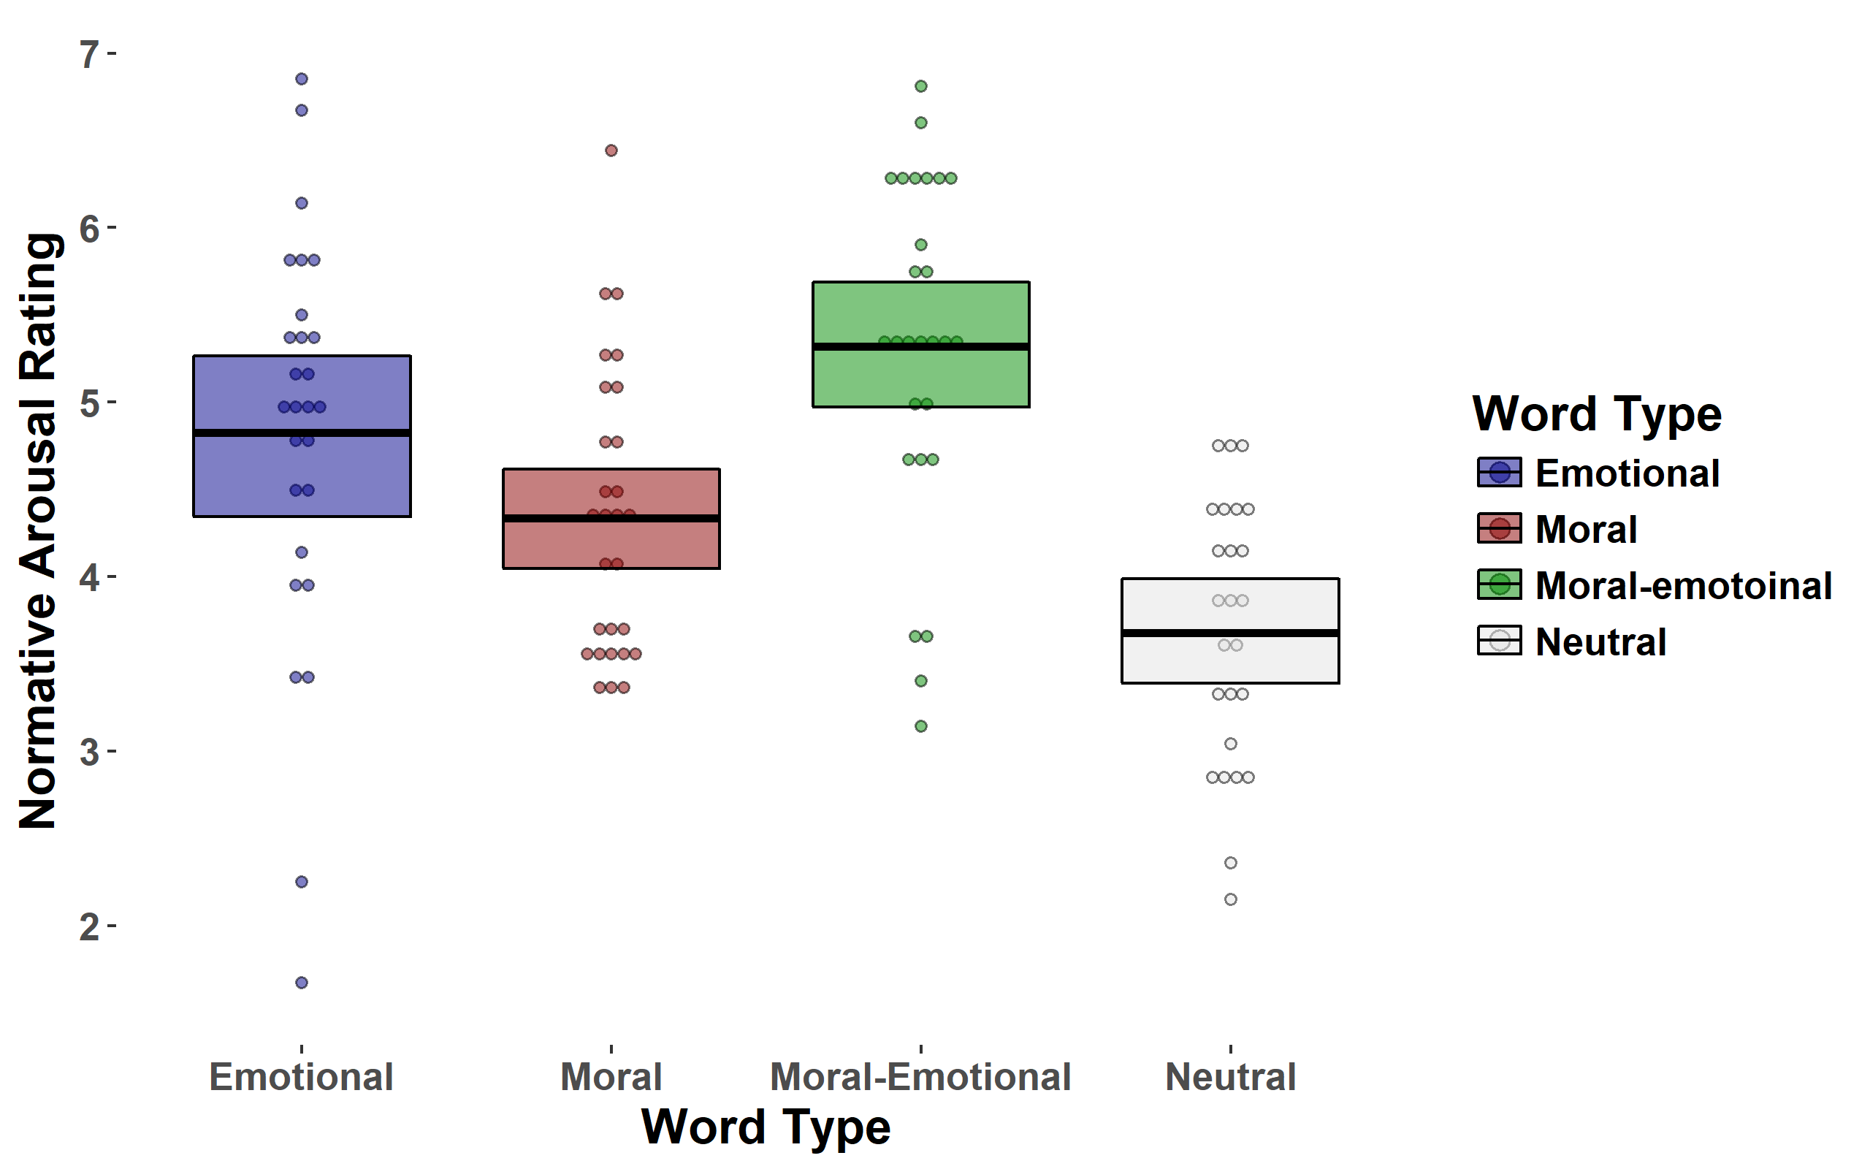

# Table S1. Words used at T2 organized by category.

|  |  |  |  |
| --- | --- | --- | --- |
|  | **Word Type** | |  |
| *Distinctly moral* | *Distinctly emotional* | *Moral-emotional* | *Neutral* |
| ally | afraid | abuse | alike |
| bias | agony | cheat | along |
| church | alarm | cruel | apply |
| clean | annoy | devil | asset |
| crime | argue | enemy | bunch |
| demon | awful | evil | coast |
| dirt | best | faith | drum |
| ethic | crazy | good | even |
| fair | crude | harm | foam |
| filth | dull | hate | focus |
| god | dumb | hell | form |
| help | empty | hero | hike |
| holy | enjoy | honor | hint |
| jail | fail | hurt | icon |
| judge | fear | kill | maze |
| jury | great | liar | novel |
| law | grief | loyal | olive |
| lewd | grim | pain | pile |
| lust | joke | rebel | press |
| mercy | loss | ruin | scale |
| moral | love | safe | shape |
| pure | mess | save | solid |
| rank | miss | shame | suite |
| right | nasty | sin | swing |
| saint | sad | spite | tile |
| spy | warm | steal | title |
| taint | weak | whore | walk |
| theft | weep | wrong | wave |

# Table S2. Characteristics of T2 word categories. Length refers to the number of letters in the word. Frequency refers to the frequency of used in the English language. Means are reported with standard deviations in parenthesis.

|  |  |  |  |  |
| --- | --- | --- | --- | --- |
|  |  | **Word Category** | |  |
|  | *Distinctly moral* | *Distinctly emotional* | *Moral-emotional* | *Neutral* |
| *Length* | 4.39  (0.74) | 4.46 (0.64) | 4.46  (0.58) | 4.57 (0.50) |
| *Frequency* | 33039.93  (56790.71) | 33746.32  (47827.21) | 33298.93  (66143.34) | 37704.79  (68520.22) |
| *Orthographic Neighbors* | 7.64  (5.62) | 8.46  (7.68) | 8.93  (7.88) | 9.86  (5.69) |
| *Phonological Neighbors* | 15.75  (12.75) | 18.89  (15.65) | 20.25  (16.03) | 19.21  (11.88) |

# Table S3. Word category, lag phase, and their interaction predicting trial-level T2 accuracy (correct/incorrect) for Study 1. Word category is a 4-level categorical variable entered as a k-1 dummy-coded variables where neutral word category is the reference group. Lag phase is a binary (early lag / late lag) effects-coded variable. Coefficients refer to odds ratios, parenthesis refer to standard errors.

|  |  |
| --- | --- |
| Distinctly moral language | 1.43*  (0.10) |
| Distinctly emotional language | 1.80*  (0.10) |
| Moral-emotional language | 1.58*  (0.10) |
| Lag phase | 2.90*  (0.09) |
| Lag phase * Distinctly moral language | 0.83  (0.13) |
| Lag phase * Distinctly emotional language | 0.96  (0.14) |
| Lag phase * Moral-emotional language | 0.77*  (0.13) |
| Constant | 1.01  (0.07) |
| Observations (participants X available trials) | 8,928 |

† *p*<.10; \**p*<.05

# Table S4. Word category, lag phase, and their interaction predicting trial-level T2 accuracy (correct/incorrect) for Study 1 *with no outliers removed.* Word category is a 4-level categorical variable entered as a k-1 dummy-coded variables where neutral word category is the reference group. Lag phase is a binary (early lag / late lag) effects-coded variable. Coefficients refer to odds ratios, parenthesis refer to standard errors.

|  |  |
| --- | --- |
| Distinctly moral language | 1.32*  (0.09) |
| Distinctly emotional language | 1.61*  (0.09) |
| Moral-emotional language | 1.44*  (0.09) |
| Lag phase | 2.75*  (0.08) |
| Lag phase * Distinctly moral language | 0.90  (0.12) |
| Lag phase * Distinctly emotional language | 0.99  (0.12) |
| Lag phase * Moral-emotional language | 0.85*  (0.12) |
| Constant | 0.90†  (0.06) |
| Observations (participants X available trials) | 10,041 |

† *p*<.10; \**p*<.05

# Table S5. Word category, lag phase, and their interaction predicting trial-level T2 accuracy (correct/incorrect) for Study 1 *in early lag phase.* Word category is a 4-level categorical variable entered as a k-1 dummy-coded variables where neutral word category is the reference group. Lag phase is a binary (early lag / late lag) dummy-coded variable. Coefficients refer to odds ratios, parenthesis refer to standard errors.

|  |  |
| --- | --- |
| Distinctly moral language | 1.43*  (0.10) |
| Distinctly emotional language | 1.80*  (0.10) |
| Moral-emotional language | 1.58*  (0.10) |
| Lag phase | 2.90*  (0.09) |
| Lag phase * Distinctly moral language | 0.83  (0.13) |
| Lag phase * Distinctly emotional language | 0.96  (0.14) |
| Lag phase * Moral-emotional language | 0.77*  (0.13) |
| Constant | 1.01  (0.07) |
| Observations (participants X available trials) | 8,928 |

† *p*<.10; \**p*<.05

# Table S6. Word category, lag phase, and their interaction predicting trial-level T2 accuracy (correct/incorrect) for Study 1 *in late lag phase.* Word category is a 4-level categorical variable entered as a k-1 dummy-coded variables where neutral word category is the reference group. Lag phase is a binary (early lag / late lag) dummy-coded variable. Coefficients refer to odds ratios, parenthesis refer to standard errors.

|  |  |
| --- | --- |
| Distinctly moral language | 1.19†  (0.10) |
| Distinctly emotional language | 1.74*  (0.10) |
| Moral-emotional language | 1.21*  (0.10) |
| Lag phase | 0.35*  (0.09) |
| Lag phase * Distinctly moral language | 1.20  (0.13) |
| Lag phase * Distinctly emotional language | 1.04  (0.14) |
| Lag phase * Moral-emotional language | 1.30*  (0.13) |
| Constant | 2.94*  (0.06) |
| Observations (participants X available trials) | 8,928 |

† *p*<.10; \**p*<.05

# Table S7. Word category, lag phase, and their interaction predicting trial-level T2 accuracy (correct/incorrect) for Study 1, *with lag phase as a continuous variable.* Word category is a 4-level categorical variable entered as a k-1 dummy-coded variables where neutral word category is the reference group. Lag phase is a continuous (1-7) variable. Coefficients refer to odds ratios, parenthesis refer to standard errors, continuous variables are grand-mean centered.

|  |  |
| --- | --- |
| Distinctly moral language | 1.28*  (0.07) |
| Distinctly emotional language | 1.74*  (0.07) |
| Moral-emotional language | 1.34*  (0.07) |
| Lag phase | 1.31*  (0.02) |
| Lag phase * Distinctly moral language | 0.95  (0.03) |
| Lag phase * Distinctly emotional language | 0.96  (0.03) |
| Lag phase * Moral-emotional language | 0.91*  (0.03) |
| Constant | 1.87*  (0.05) |
| Observations (participants X available trials) | 8,928 |

† *p*<.10; \**p*<.05

# **Table S8**. Arousal means and (standard deviations) for each T2 word type.

|  |  |  |  |  |  |
| --- | --- | --- | --- | --- | --- |
|  | | *Word Type* | |  | |
| Moral | Emotional | | Moral-emotional | | Neutral |
| 4.34  (0.82) | 4.35  (1.19) | | 5.32  (0.99) | | 3.68  (0.77) |

# Table S9. Word arousal, lag phase, and their interaction predicting trial-level T2 accuracy (correct/incorrect) for Study 1*.* Arousal is a continuous variable taken from normative ratings via Warriner, Kuperman, & Brysbaert (2013). Coefficients refer to odds ratios, parenthesis refer to standard errors, continuous variables are grand-mean centered.

|  |  |
| --- | --- |
| Arousal | 1.06*  (0.03) |
| Lag phase | 2.56*  (0.07) |
| Lag phase * arousal | 0.93  (0.03) |
| Constant | 1.43*  (0.09) |
| Observations (participants X available trials) | 8,529 |

# Table S10. Word arousal, lag phase, and their interaction predicting trial-level T2 accuracy (correct/incorrect) for Study 1*.* Arousal is a continuous variable taken from normative ratings via Warriner, Kuperman, & Brysbaert (2013). Coefficients refer to odds ratios, parenthesis refer to standard errors, continuous variables are grand-mean centered.

|  |  |
| --- | --- |
| Arousal | 0.97  (0.03) |
| Lag phase | 2.59*  (0.07) |
| Distinctly moral language | 1.38*  (0.08) |
| Distinctly emotional language | 1.96*  (0.09) |
| Moral-emotional language | 1.61*  (0.08) |
| Lag phase * arousal | 0.92*  (0.03) |
| Constant | 0.99  (0.10) |
| Observations (participants X available trials) | 8,529 |

# Table S11. Word category, lag phase, and their interaction predicting trial-level T2 accuracy (correct/incorrect) for Study 2. Word category is a 4-level categorical variable entered as a k-1 dummy-coded variables where neutral word category is the reference group. Lag phase is a binary (early lag / late lag) effects-coded variable. Coefficients refer to odds ratios, parenthesis refer to standard errors.

|  |  |
| --- | --- |
| Distinctly moral language | 1.64*  (0.09) |
| Distinctly emotional language | 1.93*  (0.09) |
| Moral-emotional language | 1.66*  (0.09) |
| Lag phase | 2.62*  (0.08) |
| Lag phase * Distinctly moral language | 0.84  (0.12) |
| Lag phase * Distinctly emotional language | 1.00  (0.13) |
| Lag phase * Moral-emotional language | 0.99  (0.12) |
| Constant | 0.99  (0.06) |
| Observations (participants X available trials) | 9,452 |

† *p*<.10; \**p*<.05

# Table S12. Word category, lag phase, and their interaction predicting trial-level T2 accuracy (correct/incorrect) for Study 2 *with no outliers removed.* Word category is a 4-level categorical variable entered as a k-1 dummy-coded variables where neutral word category is the reference group. Lag phase is a binary (early lag / late lag) effects-coded variable. Coefficients refer to odds ratios, parenthesis refer to standard errors.

|  |  |
| --- | --- |
| Distinctly moral language | 1.71*  (0.09) |
| Distinctly emotional language | 1.98*  (0.09) |
| Moral-emotional language | 1.67*  (0.09) |
| Lag phase | 2.56*  (0.08) |
| Lag phase * Distinctly moral language | 0.83  (0.12) |
| Lag phase * Distinctly emotional language | 0.98  (0.13) |
| Lag phase * Moral-emotional language | 1.01  (0.12) |
| Constant | 0.96  (0.06) |
| Observations (participants X available trials) | 9,956 |

† *p*<.10; \**p*<.05

# Table S13. Word category, lag phase, and their interaction predicting trial-level T2 accuracy (correct/incorrect) for Study 2 *in early lag phase.* Word category is a 4-level categorical variable entered as a k-1 dummy-coded variables where neutral word category is the reference group. Lag phase is a binary (early lag / late lag) dummy-coded variable. Coefficients refer to odds ratios, parenthesis refer to standard errors.

|  |  |
| --- | --- |
| Distinctly moral language | 1.64*  (0.09) |
| Distinctly emotional language | 1.93*  (0.09) |
| Moral-emotional language | 1.66*  (0.09) |
| Lag phase | 2.62*  (0.08) |
| Lag phase * Distinctly moral language | 0.84  (0.12) |
| Lag phase * Distinctly emotional language | 1.00  (0.13) |
| Lag phase * Moral-emotional language | 0.99*  (0.12) |
| Constant | 0.99  (0.06) |
| Observations (participants X available trials) | 9,452 |

† *p*<.10; \**p*<.05

# Table S14. Word category, lag phase, and their interaction predicting trial-level T2 accuracy (correct/incorrect) for Study 2 *in late lag phase.* Word category is a 4-level categorical variable entered as a k-1 dummy-coded variables where neutral word category is the reference group. Lag phase is a binary (early lag / late lag) dummy-coded variable. Coefficients refer to odds ratios, parenthesis refer to standard errors.

|  |  |
| --- | --- |
| Distinctly moral language | 1.37*  (0.09) |
| Distinctly emotional language | 1.93*  (0.10) |
| Moral-emotional language | 1.65*  (0.10) |
| Lag phase | 0.38*  (0.08) |
| Lag phase * Distinctly moral language | 1.20  (0.12) |
| Lag phase * Distinctly emotional language | 1.00  (0.13) |
| Lag phase * Moral-emotional language | 1.01  (0.13) |
| Constant | 2.61*  (0.06) |
| Observations (participants X available trials) | 9,452 |

† *p*<.10; \**p*<.05

# Table S15. Word category, lag phase, and their interaction predicting trial-level T2 accuracy (correct/incorrect) for Study 2, *with lag phase as a continuous variable.* Word category is a 4-level categorical variable entered as a k-1 dummy-coded variables where neutral word category is the reference group. Lag phase is a continuous (1-7) variable. Coefficients refer to odds ratios, parenthesis refer to standard errors, continuous variables are grand-mean centered.

|  |  |
| --- | --- |
| Distinctly moral language | 1.47*  (0.07) |
| Distinctly emotional language | 1.91*  (0.07) |
| Moral-emotional language | 1.65*  (0.07) |
| Lag phase | 1.25*  (0.02) |
| Lag phase * Distinctly moral language | 0.93*  (0.03) |
| Lag phase * Distinctly emotional language | 0.99  (0.03) |
| Lag phase * Moral-emotional language | 1.00  (0.03) |
| Constant | 1.72*  (0.05) |
| Observations (participants X available trials) | 9,452 |

† *p*<.10; \**p*<.05

# Table S16. Word arousal, lag phase, and their interaction predicting trial-level T2 accuracy (correct/incorrect) for Study 2*.* Arousal is a continuous variable taken from normative ratings via Warriner, Kuperman, & Brysbaert (2013). Coefficients refer to odds ratios, parenthesis refer to standard errors, continuous variables are grand-mean centered.

|  |  |
| --- | --- |
| Arousal | 1.08*  (0.03) |
| Lag phase | 2.44*  (0.03) |
| Lag phase * arousal | 0.93†  (0.04) |
| Constant | 1.51*  (0.03) |
| Observations (participants X available trials) | 8,953 |

† *p*<.10; \**p*<.05

# Table S17. Word arousal, lag phase, and their interaction predicting trial-level T2 accuracy (correct/incorrect) for Study 2*.* Arousal is a continuous variable taken from normative ratings via Warriner, Kuperman, & Brysbaert (2013). Coefficients refer to odds ratios, parenthesis refer to standard errors, continuous variables are grand-mean centered.

|  |  |
| --- | --- |
| Arousal | 0.97  (0.03) |
| Lag phase | 2.54*  (0.05) |
| Distinctly moral language | 1.37*  (0.08) |
| Distinctly emotional language | 1.94*  (0.08) |
| Moral-emotional language | 1.61*  (0.09) |
| Lag phase * arousal | 0.92*  (0.04) |
| Constant | 1.02  (0.06) |
| Observations (participants X available trials) | 8,953 |

† *p*<.10; \**p*<.05

# Table S18. Attentional capture index predicting retweet count in Study 3*.* Table displays both sum and mean specifications of the attentional capture index as described in Study 3 methods. Coefficients refer to incident rate ratios, parenthesis refer to standard errors.

|  |  |  |
| --- | --- | --- |
|  | Sum | Mean |
| Attentional capture index | 1.38*  (0.05) | 1.49*  (0.16) |
| Constant | 0.78*  (0.04) | 0.77*  (0.11) |
| Observations (original messages) | 47,552 | 47,552 |

† *p*<.10; \**p*<.05

# Table S19. Attentional capture index predicting retweet count in Study 3 with quadratic component*.* All predicters were grand-mean centered.Coefficients refer to incident rate ratios, parenthesis refer to standard errors.

|  |  |
| --- | --- |
| Attentional Capture Index | 1.54*  (0.08) |
| Attentional Capture Index, Quadratic | 0.87†  (0.08) |
| Constant | 1.03†  (0.01) |
| Observations | 47,552 |

† *p*<.10; \**p*<.05

1. https://corpus.byu.edu/coca/
2. http://clearpond.northwestern.edu/englishpond.php